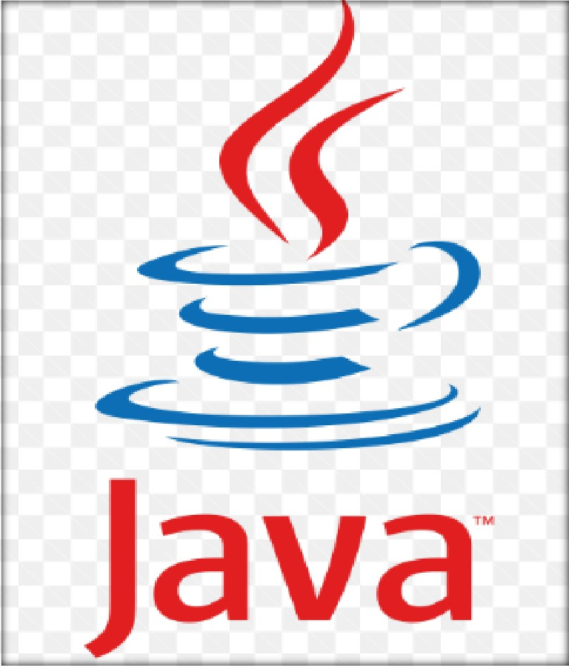

MCS- 024

OBJECT ORIENTED TECHNOLOGIES AND JAVA PROGRAMMING

By – Shivam Shrivastav - SS

- Basics of OOPS: -
 Class
- Class is a collection of data members and methods.
- It is a logical entity.
- It is a user defined data type.
- Class is the blue print of an object.
- Syntax of a class in java: -
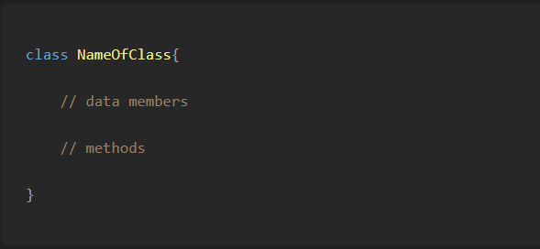
 Object
- It is a real-world entity that has stage and behaviour.
- For ex table, chair, student, etc.
- It is a physical representation of class.
- It is an instance of a class.
- Syntax of an object in java: -
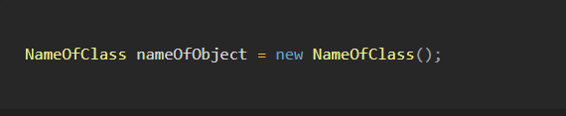

This Keyword
 This is a keyword in java which is used to store the address of currently created object.
The following operations are performed using this: -
- This can be used to refer current class instance variable.
- This can be used to invoke current class method (implicitly).
- This () can be used to invoke current class constructor.
- This can be passed as an argument in the method call.

- This can be passed as argument in the constructor call.
- This can be used to return the current class instance from the method.
  - Example of this keyword: -
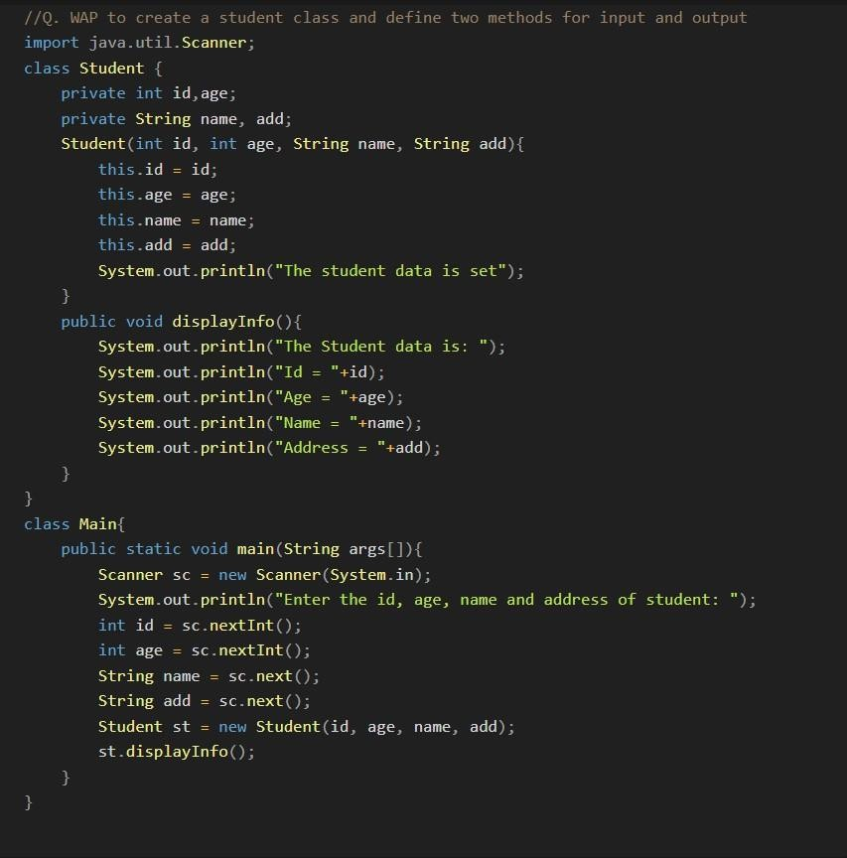

Constructor
  - Constructor is a special type of method used to initialize the values of instance data members. It is automatically invoked at the time of creating new object. If we don’t create any constructor in our class then compiler automatically creates a default constructor.

  - Properties of constructor are:
- Constructor is created in public or default access specifier.
- Constructor never returns any kind of value including void.

- Constructor has the same name as class name.
- It is automatically invoked at the time of creating new object.

  - There are two types of Constructors in java:
    - Default constructor: - A constructor which takes no arguments as a parameter is called default constructor. For ex: -
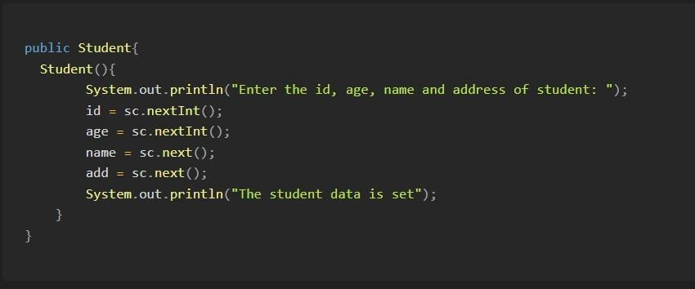

Parameterized constructor: -
For ex: -
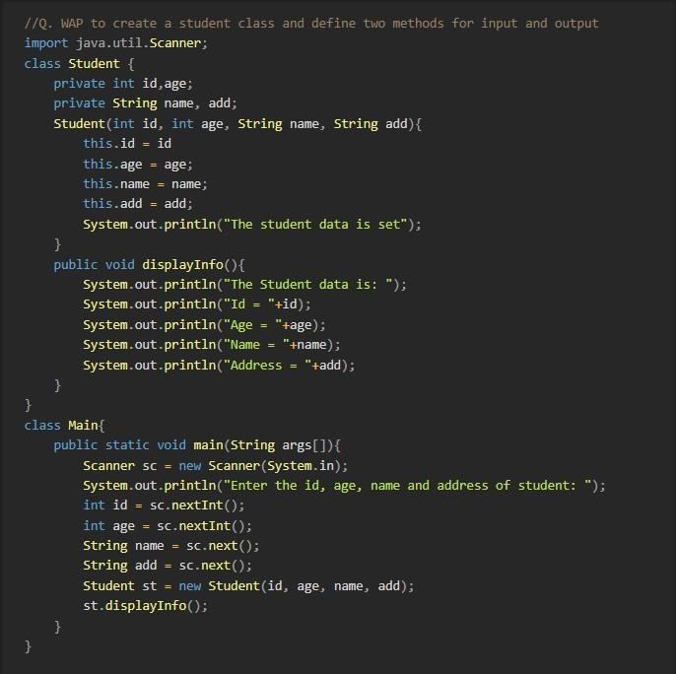

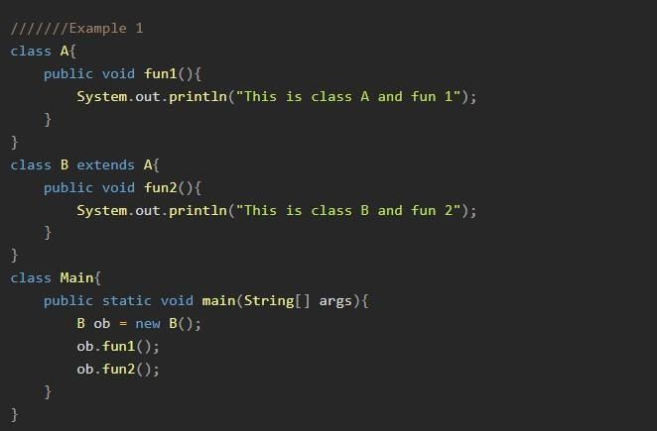
Inheritance
  - Inheritance is the process in which one class acquires the all properties and behaviors of another class.
- Child class/derived class: - A class which inherits the all properties and behaviors of another class is called child class.
- Base class/ parent class: - A class which is inherited by another class is called parent class/base class.

  - Advantages of inheritance: -
- Code reusability.
- Time effective.
- Cost effective.
- Easily maintainable.


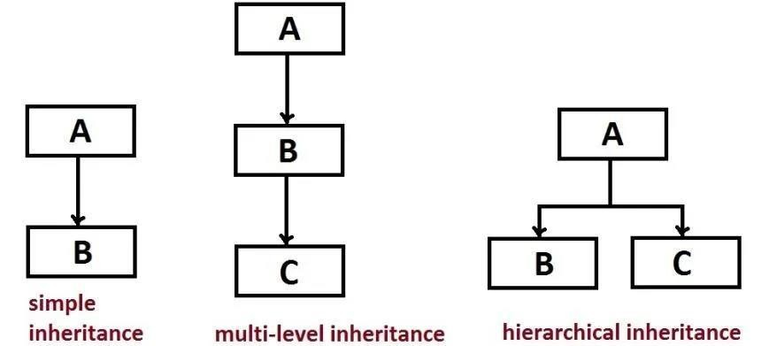
 There are mainly three types of inheritance available in java: -
- Single level inheritance: - When a base class is inherited by only one derived class. For example: -

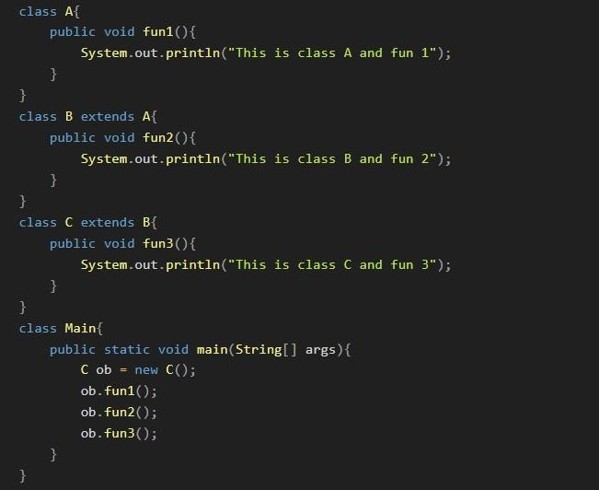
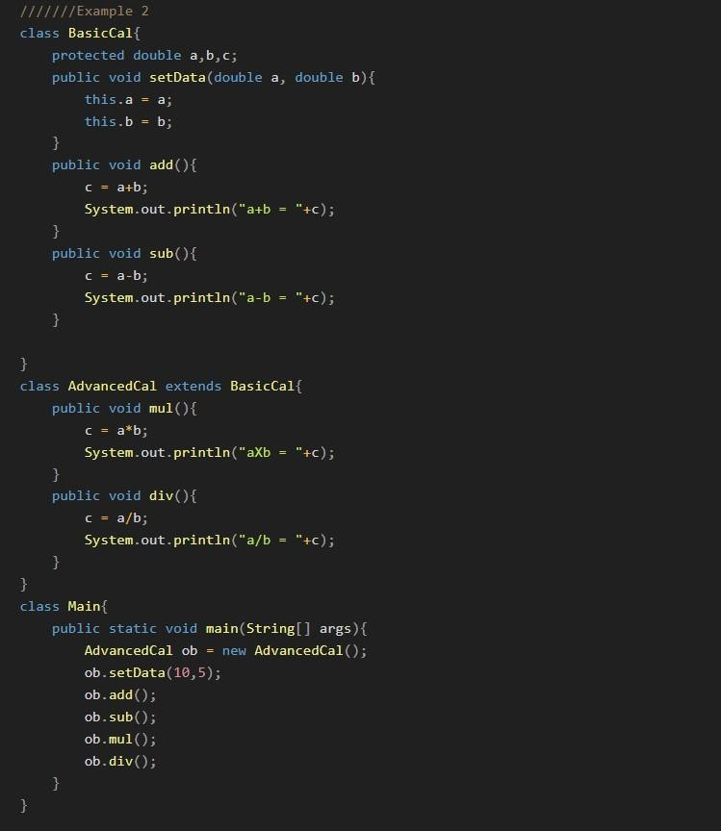

- Multi-level inheritance: - When a derived class is inherited by another derived class. For example: -

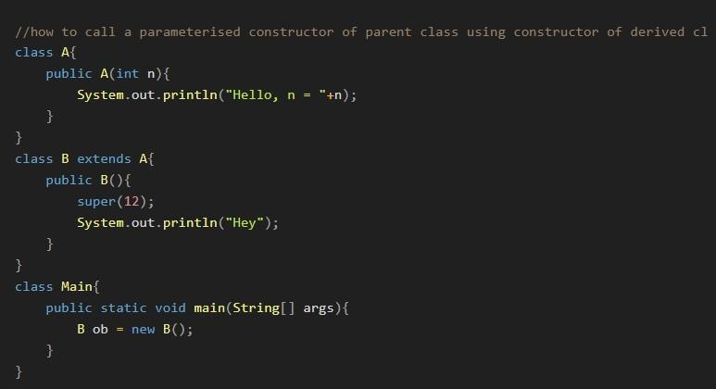
- Hierarchal inheritances: - When a base class is inherited by multiple derived classes. For example: -
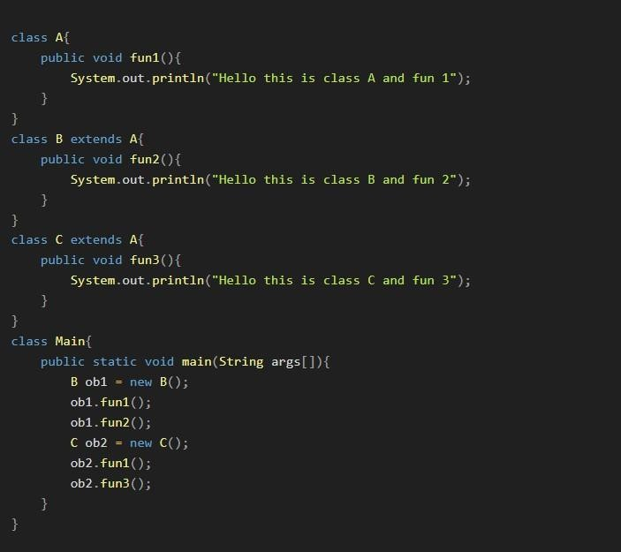

Super Keyword
- The super variable in java is a reference variable which is used to refer immediate parent class object. Whenever we create the instance of subclass, an instance of 1parent class is created implicitly which is referred by super reference variable.

- Usage of super keyword: -
- Super can be used to refer immediate parent class instance variable.
- Super can be used to invoke immediate parent class method.
- Super () can be used to invoke immediate parent class constructor.

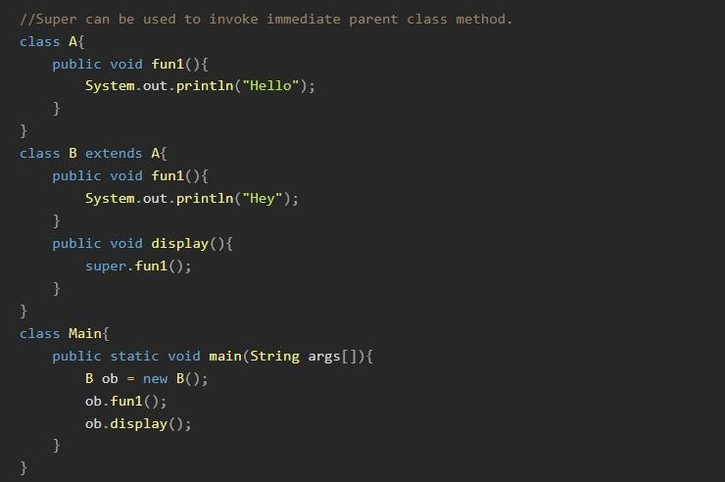
Examples:

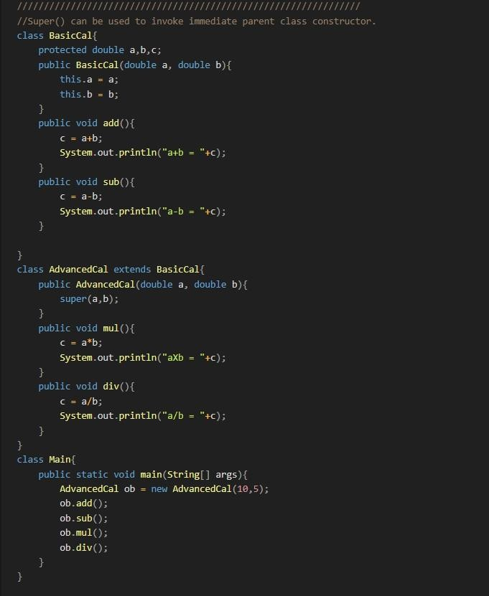

Polymorphism

- Polymorphism in Java is a concept by which we can perform a single action in different ways. Polymorphism means “many forms”, and it occurs when we have many classes that are related to each other by inheritance.

- Advantages of polymorphism: -
- Code reusability
- Flexibility and extensibility
- Dynamic method invocation
- Method overloading
- Interface implementation
- Reduced Code Complexity
 Types of polymorphism: -

- Compile time polymorphism: - When we overload static methods in java, then it’s called static/compile time polymorphism. When we define more than one method with same name but different in number of arguments or types of argument is called method overloading. For example: -
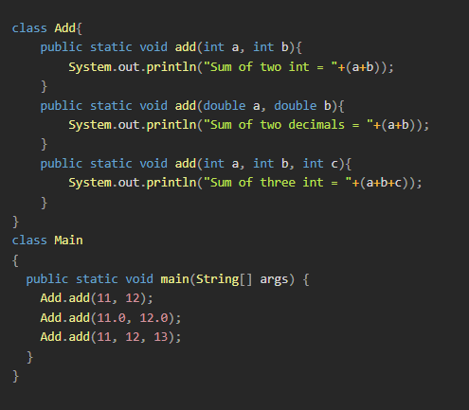

- Run time polymorphism: - Run time polymorphism is a process in which a call to an overridden method is resolved at runtime rather than compile time.
  - In this process, an overridden method is called through the reference variable of a super class.
For ex: -
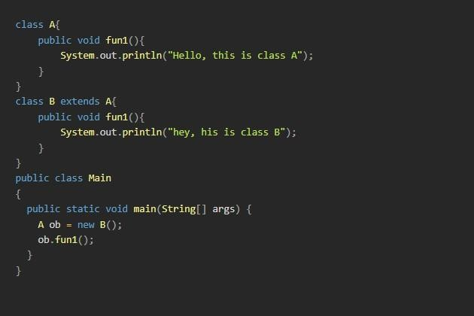

- Upcasting

  - If the reference variable of parent class refers to the object of child class, it is known as upcasting. For ex: A ob = new B();

  - When child class redefine the parent class method, then it is called method overriding.

Encapsulation
  - Binding or wrapping the data members and methods into a single unit is called encapsulation.
  - We can achieve encapsulation using getter and setter methods. For example: -
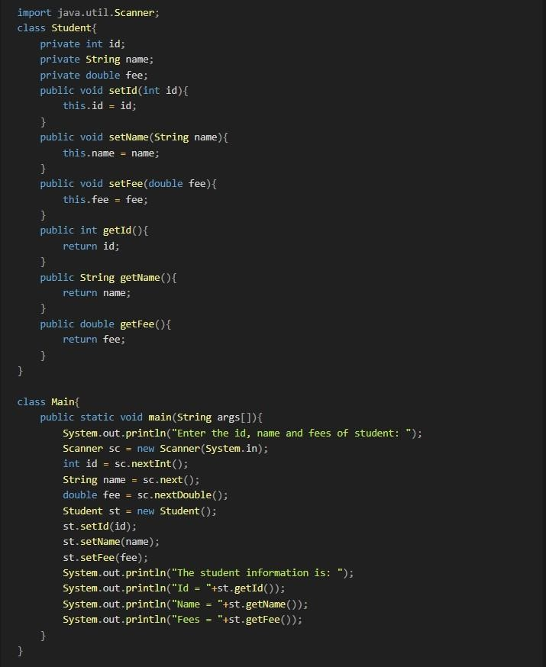

Abstraction
  - Hiding the implementation details and showing only functionality to the outside user is called abstraction. There are two ways to achieve abstraction in java: -
- Abstract class: - A class which is declared with abstract keyword is called abstract class. Abstract class can contain data member and constructor. It also contains abstract and non-abstract methods. Properties of abstract class: -
  - It is declared with abstract keyword.
  - We cannot create the instance of abstract class.
  - It is used to achieve abstraction in java.
  - We can create reference variable of abstract class.
  - Abstract class can contain data members and constructors also.
  - All abstract methods must be implemented by child class. (A method without definition is called abstract method).
  - Abstract class can be used to achieve up to 100% abstraction.
  - For example:
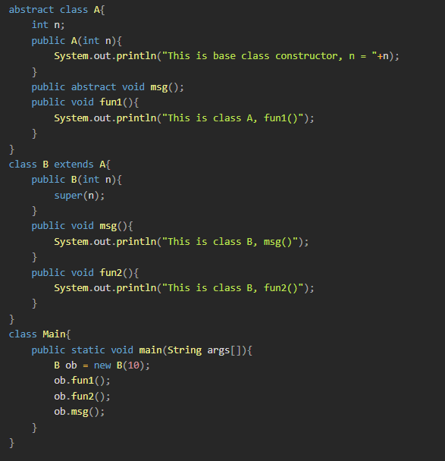

- Interface: - It is the blueprint of a class. It has static constants and abstract methods. The interface is used to achieve 100% abstraction in java. There can only be abstract methods in java interface, not method body. Java compiler adds public and abstract before interface methods. It adds public, static
and final keywords before data members. We cannot define constructor in java interface. All methods of interface must be defined by child class. For ex:

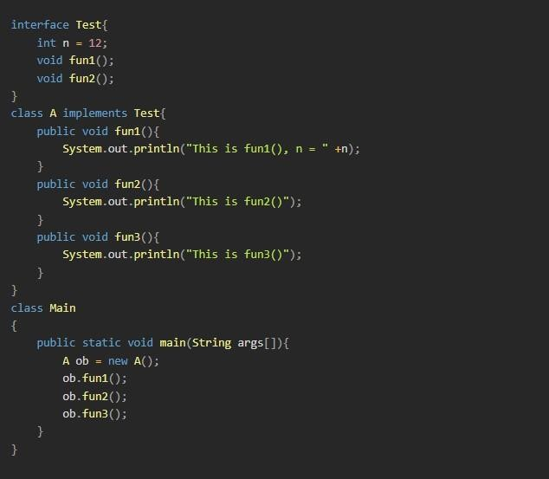

Q: - LAST YEAR PAPER QUESTION IS GIVEN BELOW?

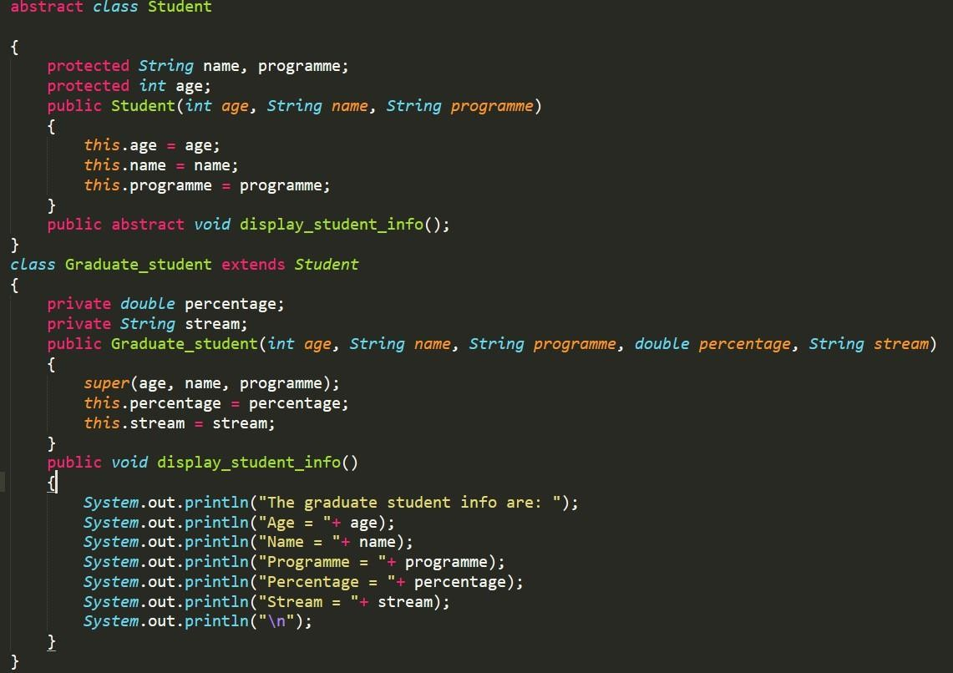
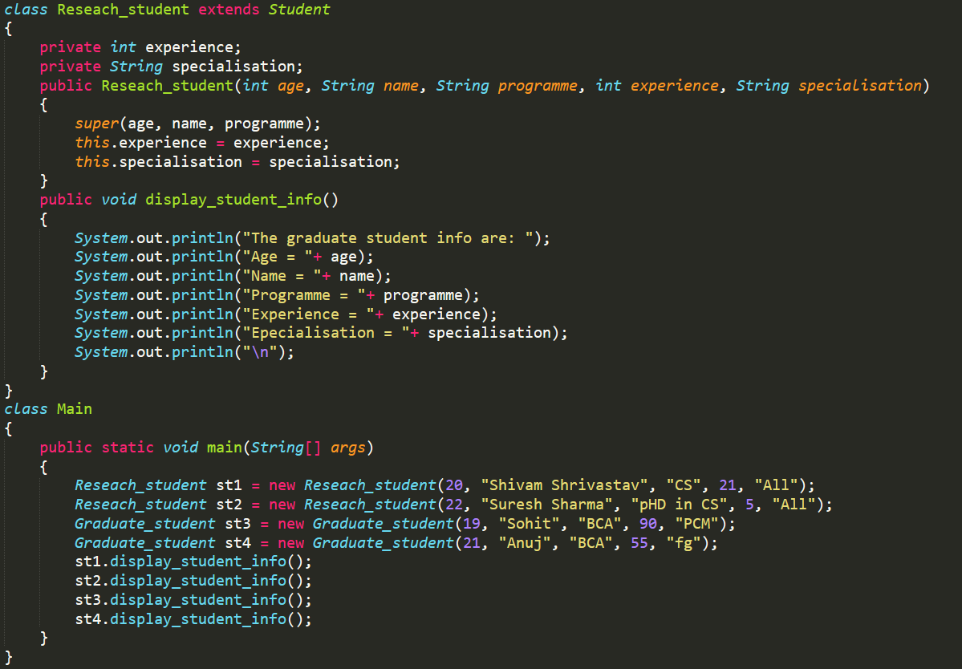

Q: - LAST YEAR PAPER QUESTION IS GIVEN BELOW?
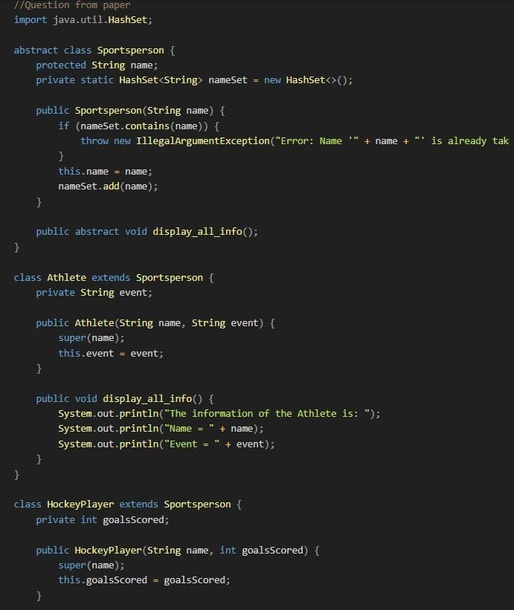
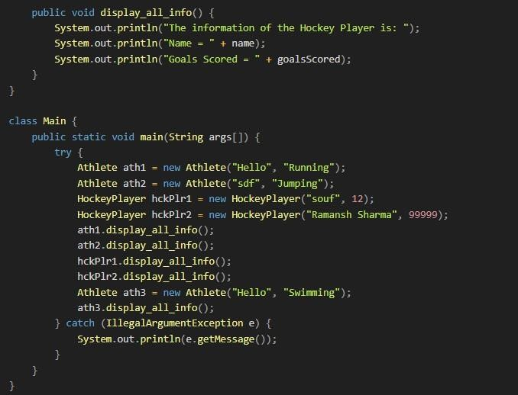

Final Keyword
 The Final keyword in java is used to restrict the user. It can be used in many contexts:
- Variable: - If you make any variable as final, you cannot change the value of final variable (it will be constant). The final keyword can be applied with variables, a final variable that have no value is called blank final variable or uninitialized final variable. It can be initialized in the constructor only. The blank final variable can be static also which will be initialized in the static block only. For example: -
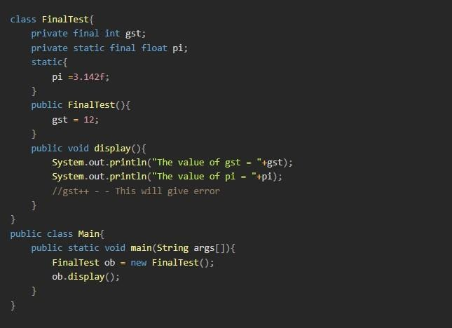

- Method: - If you make any method as final, you cannot override it.

For example: -

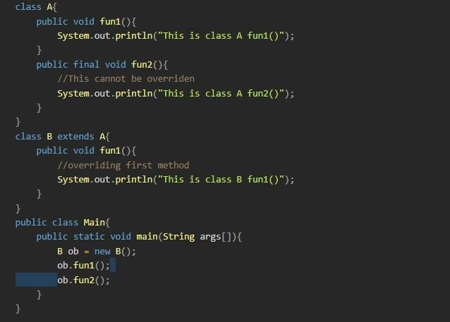

- Class: - If you declare any class with final keyword, then that class cannot be inherited by other classes.
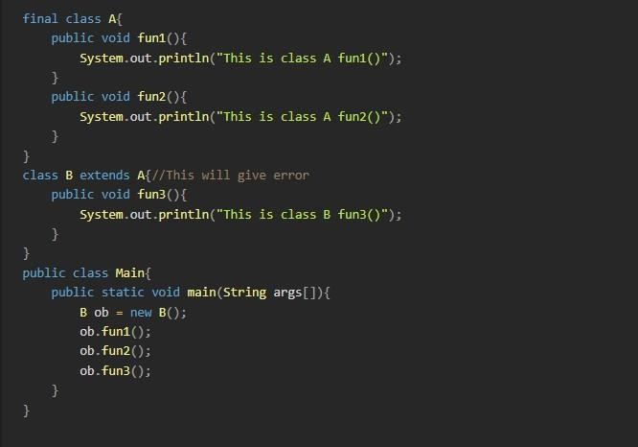

EXCEPTION
- Exception: -
- In Java, an exception is an event that occurs during the execution of a program that disrupts the normal flow of instructions/program. These exceptions can occur for various reasons, such as invalid user input, file not found, or division by zero. When an exception occurs, it is typically represented by an object of a subclass of the java lang. Exception class.

- Exception Handling: -
- Exception handling is a mechanism to handle runtime errors such as ClassNotFoundException, IO Exception, SQL Exception, Remote Exception, etc.

- Advantages of Exception Handling:
- The core advantage of exception handling is to maintain the normal flow of the application.
- Hierarchy of Java Exception classes
- The java lang. Throwable class is the root class of Java hierarchy inherited by two subclasses: Exception and Error. The hierarchy of Java Exception classes is given below:
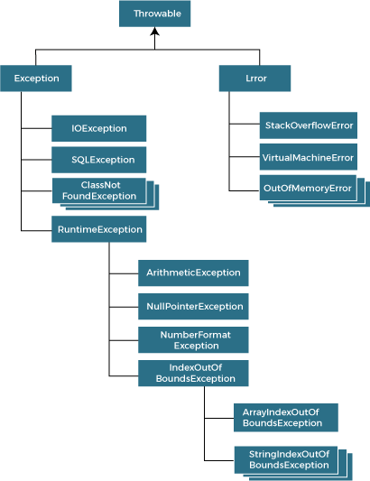

- Types of Exceptions in Java

- There are mainly two types of exception in Java:
- Checked Exception: - Checked exceptions are the exceptions that are checked at compile time. Examples of checked exception include:
  - IO Exception
  - SQL Exception
  - Parse Exception
  - ClassNotFoundException
- Unchecked Exception: - Unchecked exceptions, also known as runtime exceptions, are not checked at compile-time. Examples of unchecked exception include:
  - NullPointerException
  - ArrayIndexOutOfBoundException
  - ArithmeticException
  - IlleagalArgumentException

- Java Exception Keywords: -

 There are 5 types of keywords used to perform exception handling in java: -
- Try: - The try keyword is used to specify a block where we should place an exception code. It means we can’t use try block alone. The try block must be followed by either catch or finally.
- Catch: - The “catch” block is used to handle the exception. It must be preceded by try block which means we can’t use catch block alone. It can be followed by finally block later.
- Throw: - The throw keyword is used to throw an exception.
- Finally: - The finally block is used to execute the necessary code of the program. It is executed whether an exception is handled or not.
- Throws: - The throws keyword is used to declare exceptions It specifies that there may occur an exception in the method. It doesn’t throw an exception. It is always used with method signature.

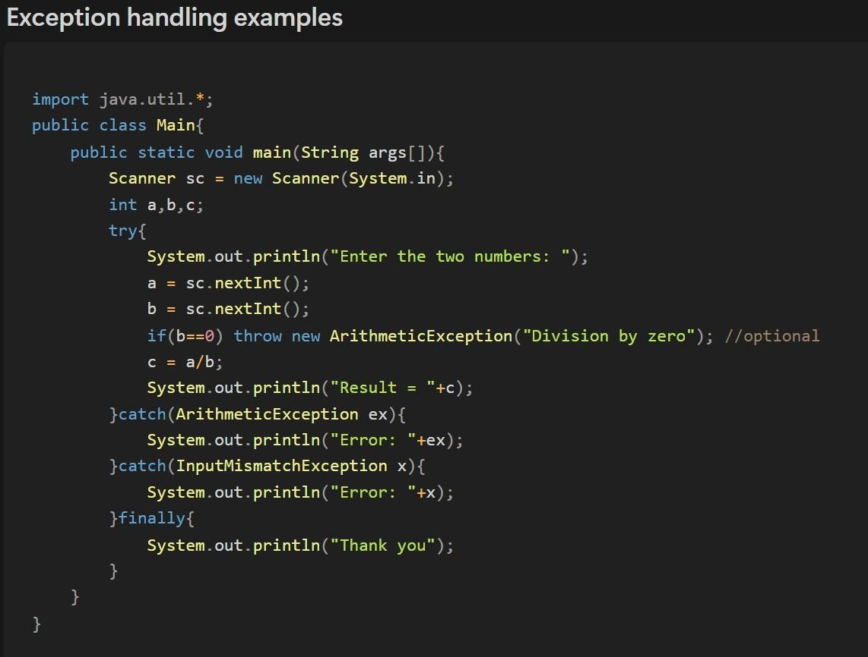

File handling
 It is a process to store permanently using our program.

- File: -

  - In java, a file is an abstract datatype. A named location used to store related information is known as a file. There are several operations like creating a file, getting information about file, updating/deleting the content of file.

- Stream: -

  - A series/sequence of data is referred to as a Stream. In java, stream is classified into two types: -
- Byte stream: - Byte stream is mainly involved with byte data. A file handling process with a byte stream is a process in which an input is provided and executed with the byte data. There are two subclasses of Byte stream:
  - Input stream class (for reading data)
  - Output stream class (for writing data)
- Character stream: - Character stream is mainly involved with character data. A file handling process with a character stream is a process in which an input is provided and executed with the character data. Byte Stream is the base class of Character stream. There are two subclasses of Character Stream:
  - Reader classes (for reading data)
  - Writer classes (for writing data)

Java File Classes Methods: -
- canRead (): - Checks if the file is readable or not and returns a Boolean.
- canWrite (): - Checks if the file is editable or not and returns a Boolean.
- createNewFile (): - For creating new file.
- exists (): - checks if a file exists.
- delete (): - Deleting a particular file.

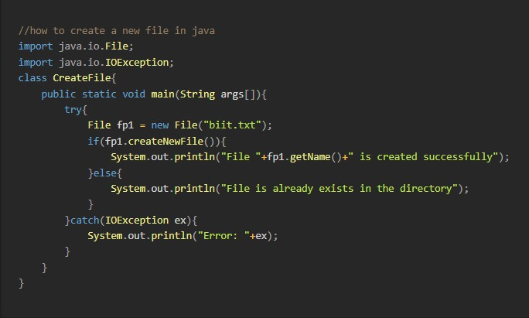
- getName (): - Returns the name of the file from a file pointer.
- getAbsolutePath (): - Returns the absolute path of a file using file pointer.
- length (): - returns number of characters in a file.
- mkdir (): - creates new directory.
- list (): - Used to get data in form of a list (like an array with different datatype).

File Operations: -

- We can perform following operations on file: -
- Create new file.
- Get information about file.
- Write to a file.
- Read from a file.
- Delete a file.

  - How to create a file: -
- Syntax of file: -
- File nameOfPointer = new File(fileName/filePath)
- for example:

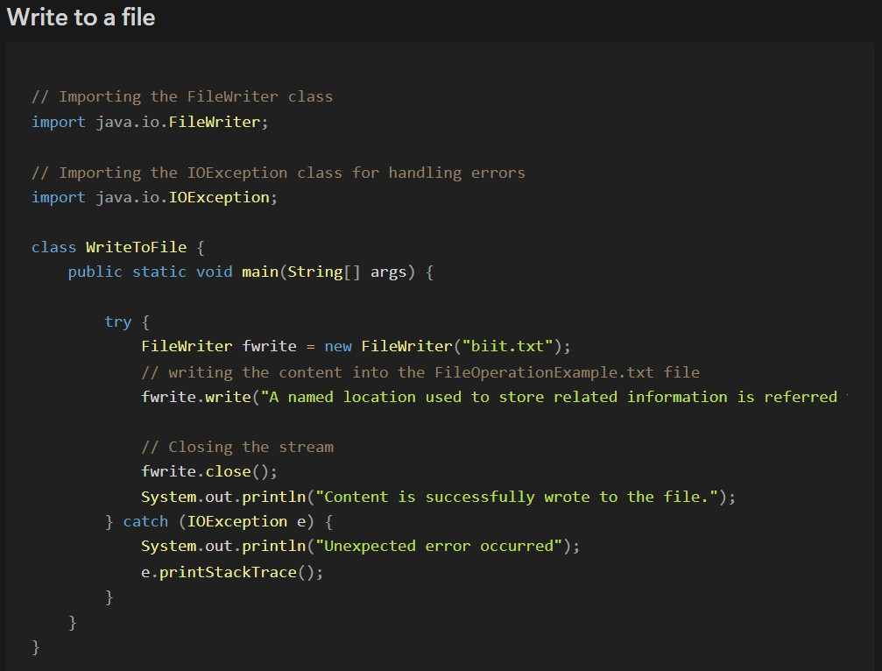

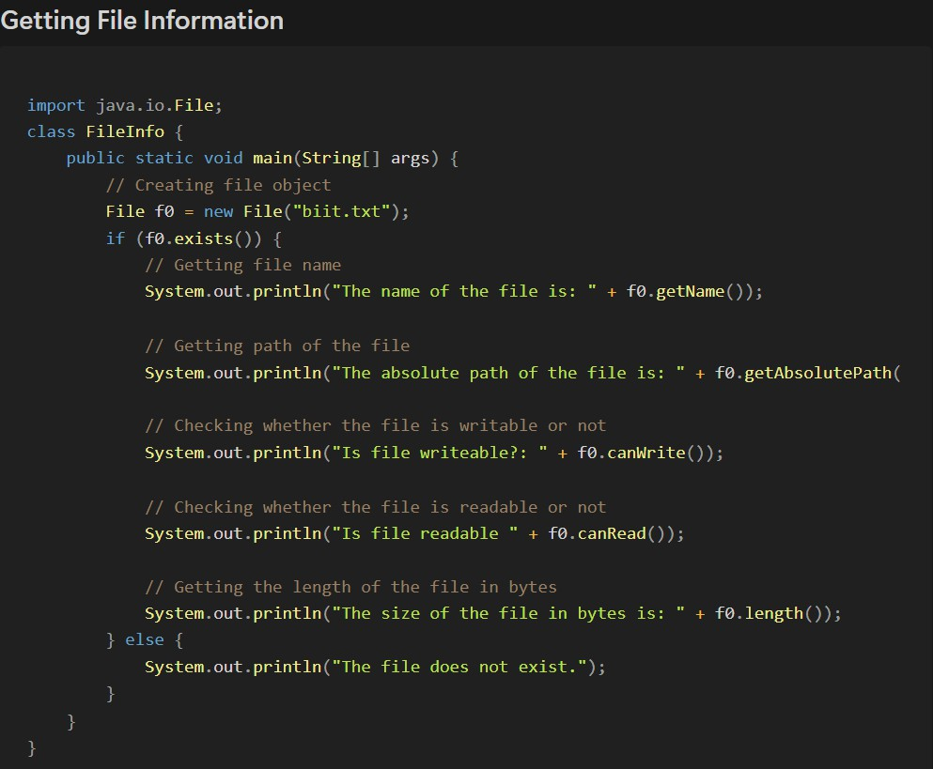

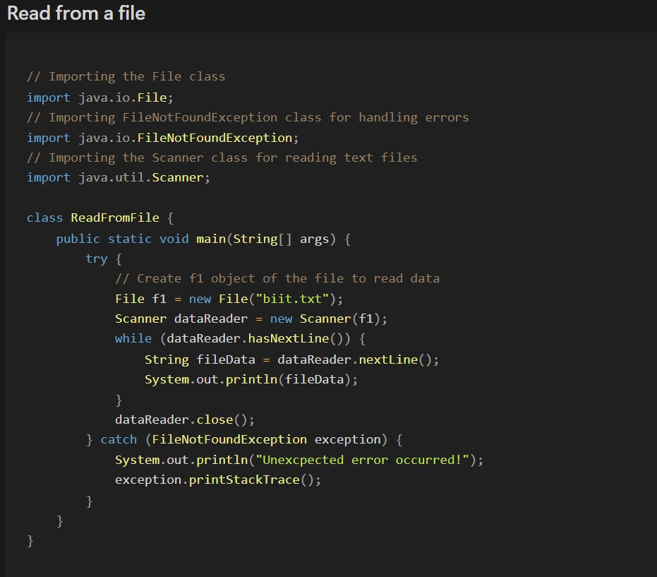

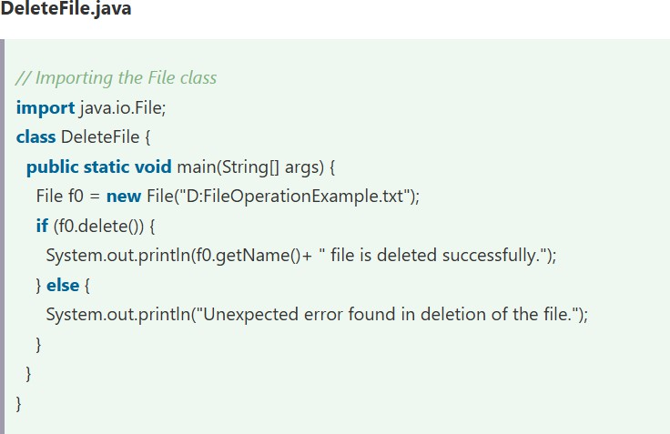

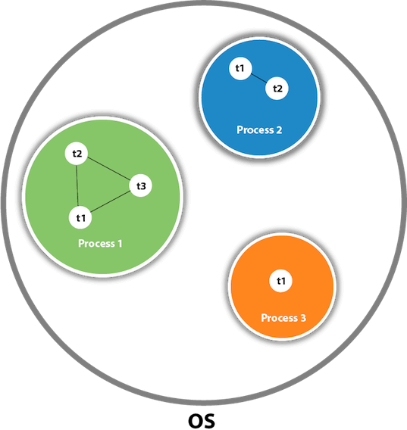
MULTITHREADING
- Multithreading in java is a process of executing multiple threads simultaneously.

- A Thread is a light weight subprocess, the smallest unit of processing. Multiprocessing and multi-threading, both are used to achieve multitasking.

  - Advantage of Multithreading: -
- It doesn’t block the user.
- You can perform many tasks together.
- Thread is independent, so it doesn’t affect other threads.
- Multithreading can significantly enhance the performance of our application

 Multitasking: -

- Multitasking is the process of executing multiple tasks simultaneously. We use multitasking to utilise the CPU. Multitasking can be achieved using two ways: -
- Process based multitasking (multiprocessing)
- Thread based multitasking (multithreading)

 Java Thread States / Lifecycle of thread: -

- New: A thread that has been created but not yet started.
- Runnable: A thread that is ready to run and waiting for CPU time.
- Blocked: A thread that is blocked waiting for a monitor lock.
- Waiting: A thread that is waiting indefinitely for another thread to perform a particular action.
- Timed Waiting: A thread that is waiting for another thread to perform an action for up to a specified waiting time.
- Terminated: A thread that has completed its task.
  - As shown in the above figure, a thread is executed inside the process. There is context- switching between the threads. There can be multiple processes inside the OS, and one process can have multiple threads.

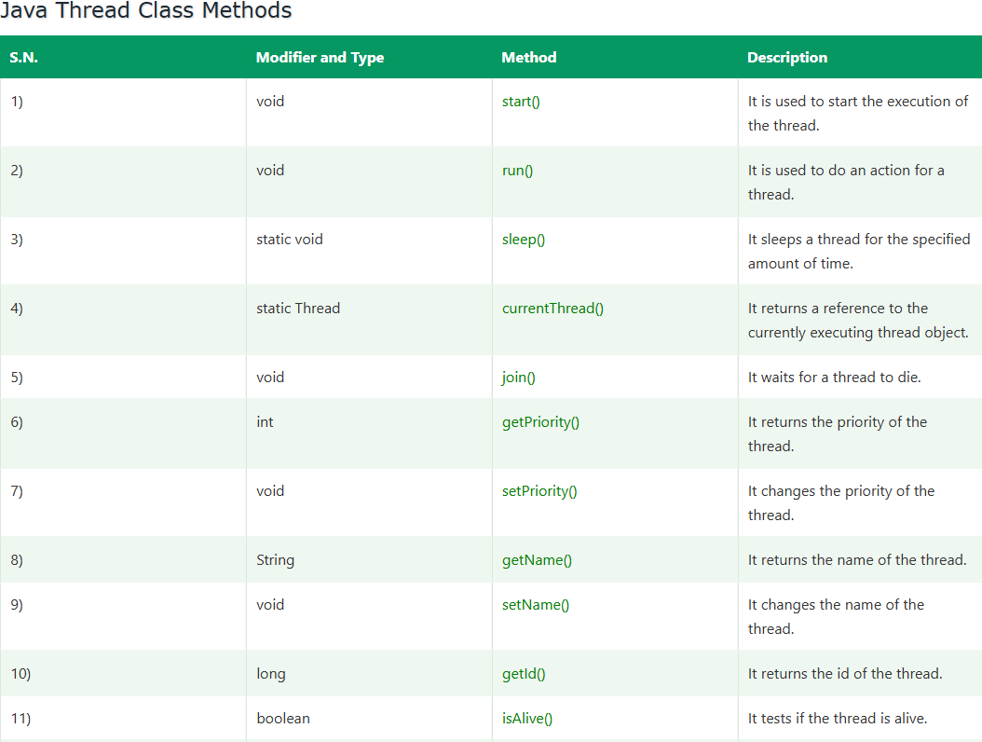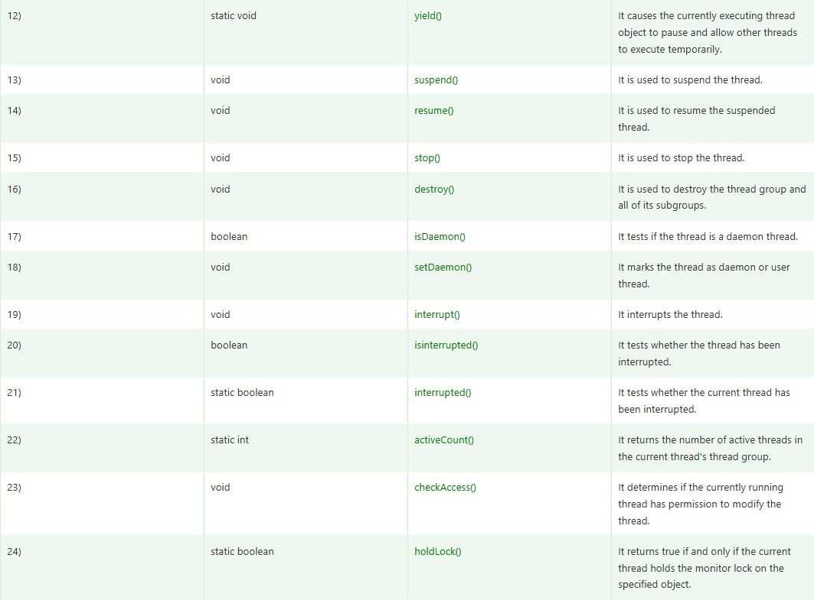

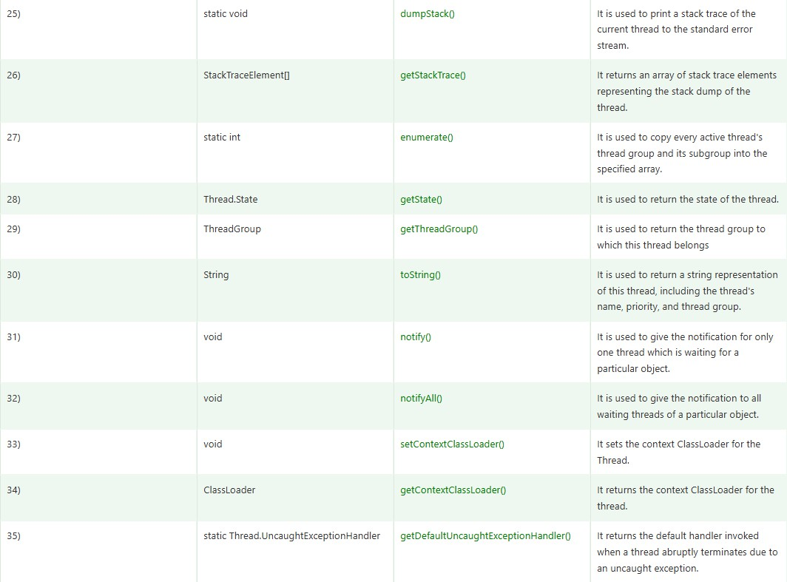

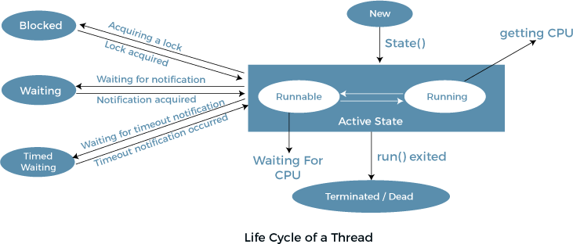

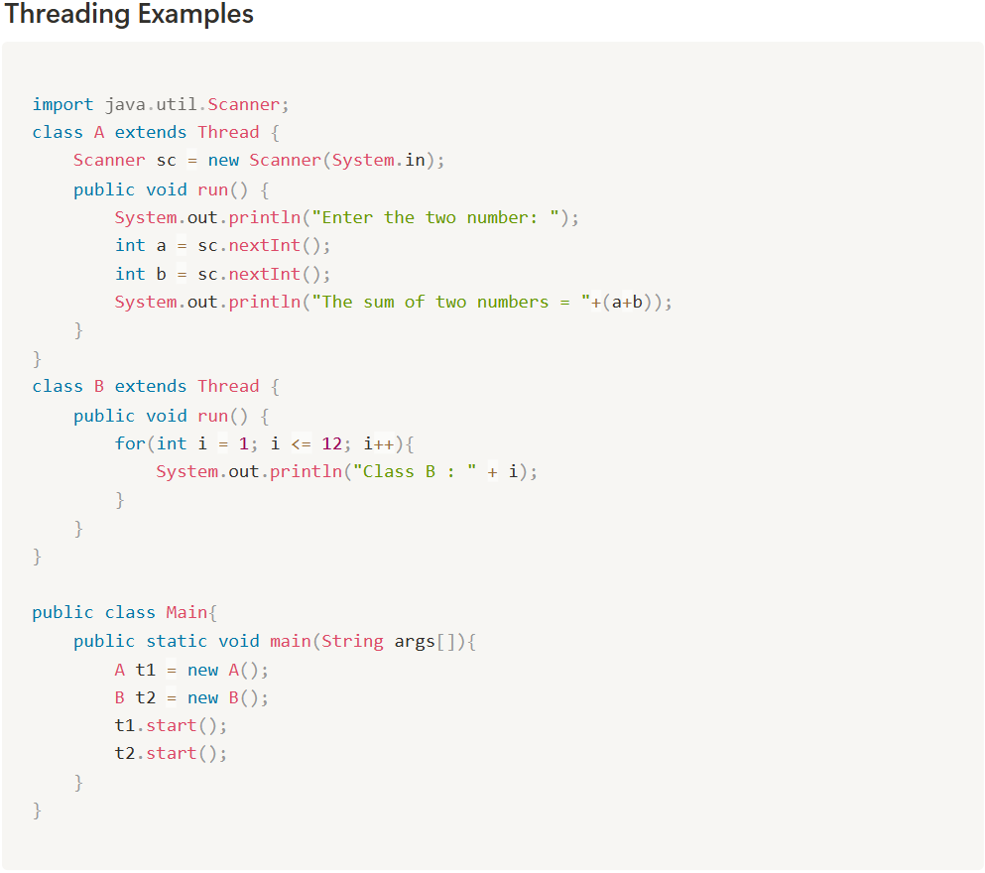
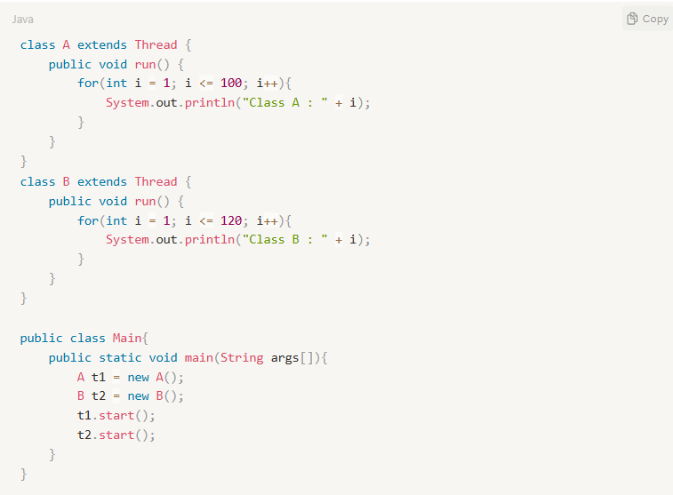
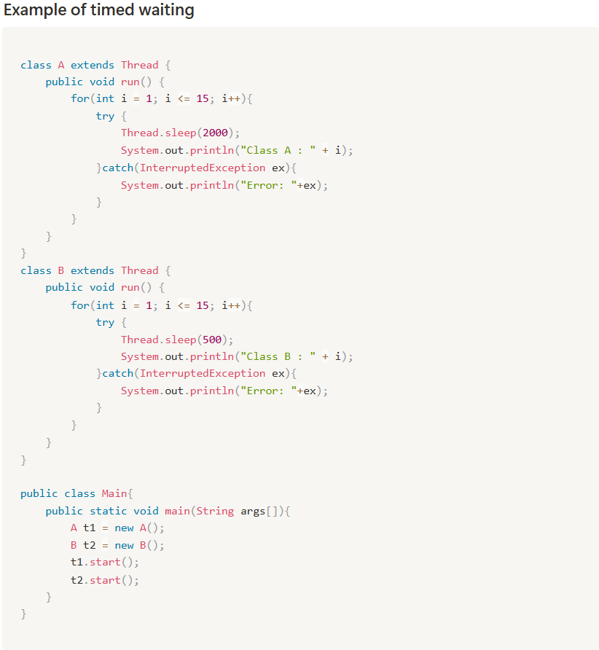

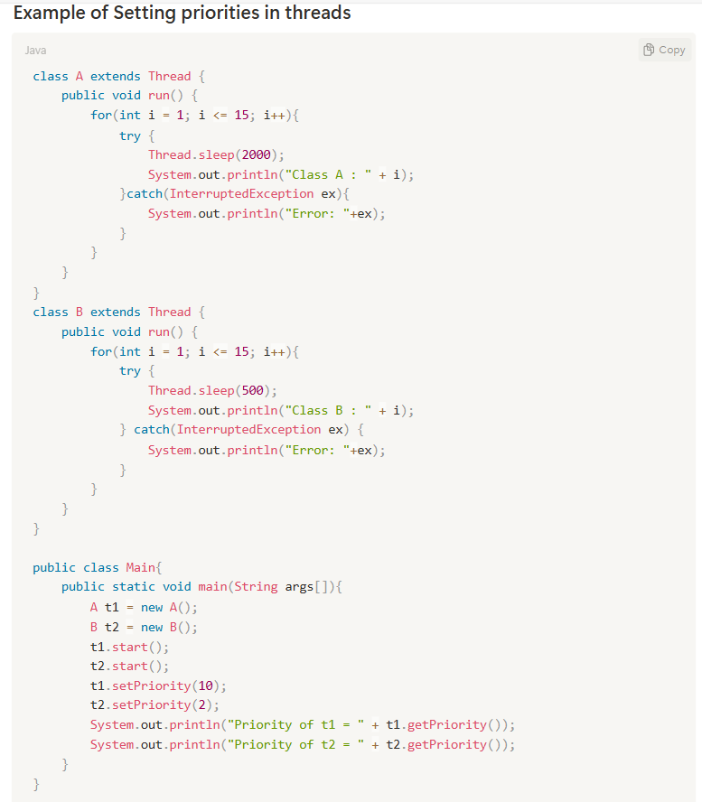

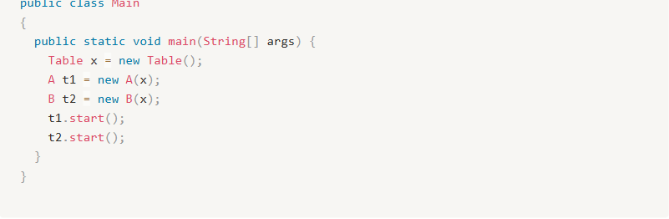
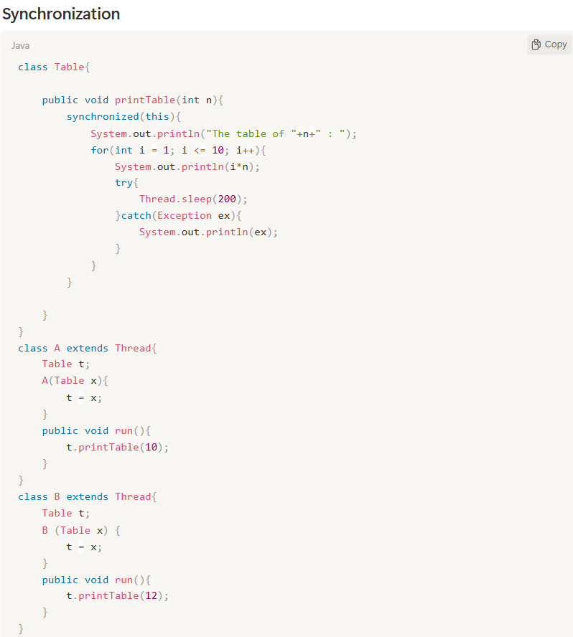

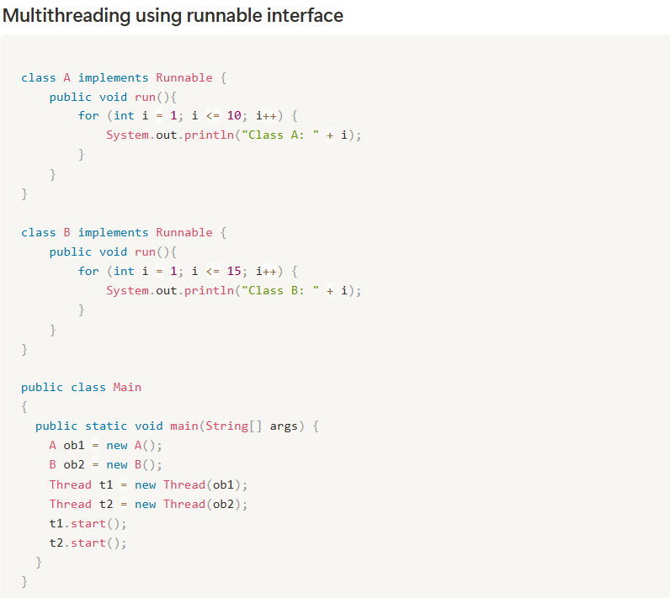

AWT (Abstract Window Toolkit)

- Abstract window Toolkit is an API (Application Programing Interface) to develop Graphical User Interface (GUI) or window-based applications in java.

- Java AWT components are platform-dependent, i.e. components are displayed according to the view of operation system. AWT is heavy weight i.e. its components are using the resources of underlying operating system (OS).

- The java.awt package provides classes for AWT API such as Text Field, Label, Text Area, Radio Button, Checkbox, Choice, List, etc.

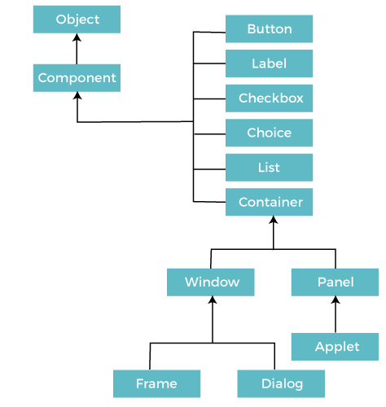
Java AWT Hierarchy:

Components: -

All the elements like the button, text fields, scroll bars, etc. are called components. In Java AWT, there are classes for each component as shown in above diagram. In order to place every component in a particular position on a screen, we need to add them to a container.

Container: -

The Container is a component in AWT that can contain another components like buttons, text fields, labels etc. The classes that extend Container class are known as container such as Frame, Dialog, and Panel.
- Event Handling in java: -

Changing the state of an object is known as event. For example, click on button, dragging mouse, etc. The java.awt. event package provides many event classes and listener interfaces for event handling.

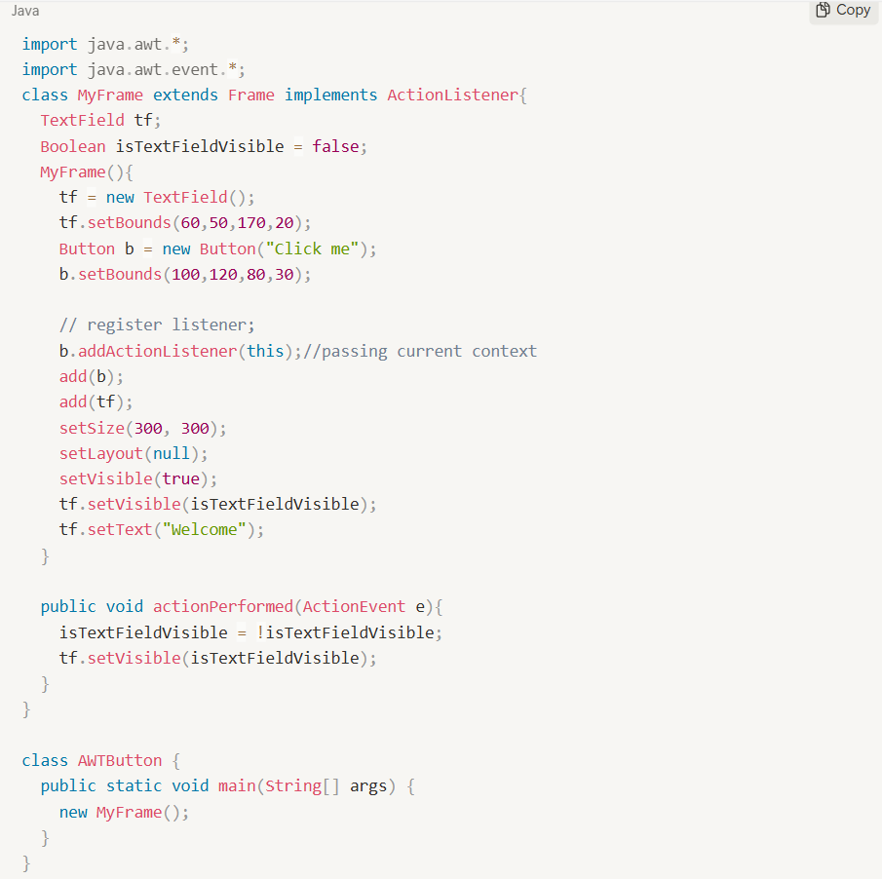
For example:

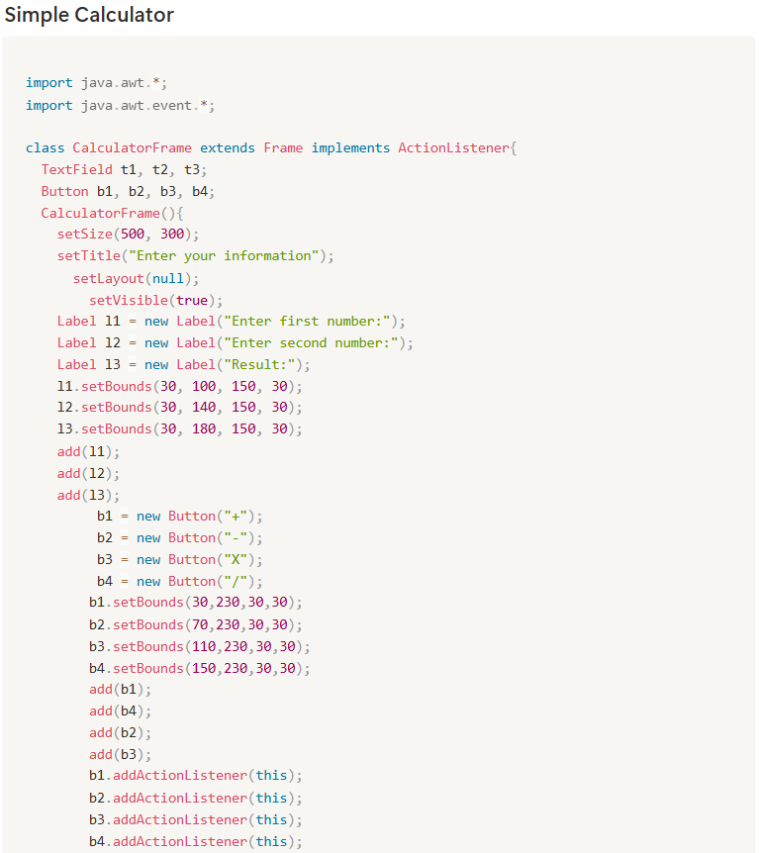

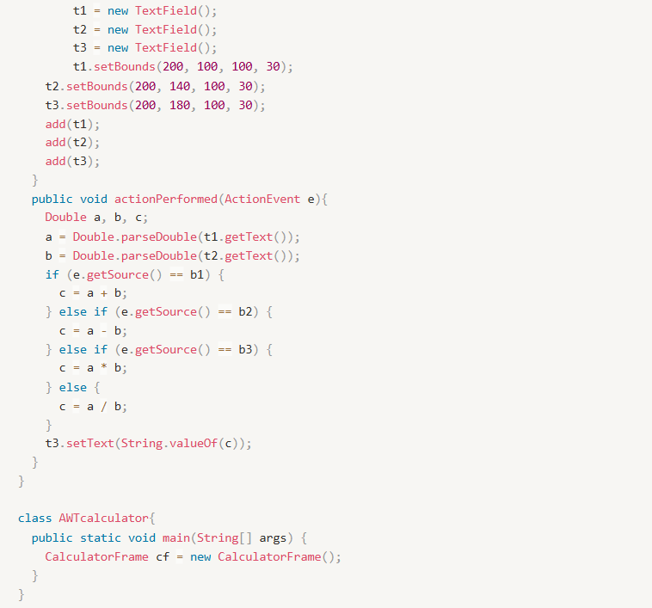

rmi (REMOTE method INVOCATION)

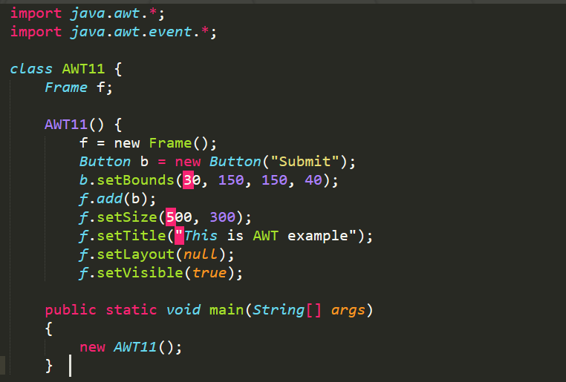
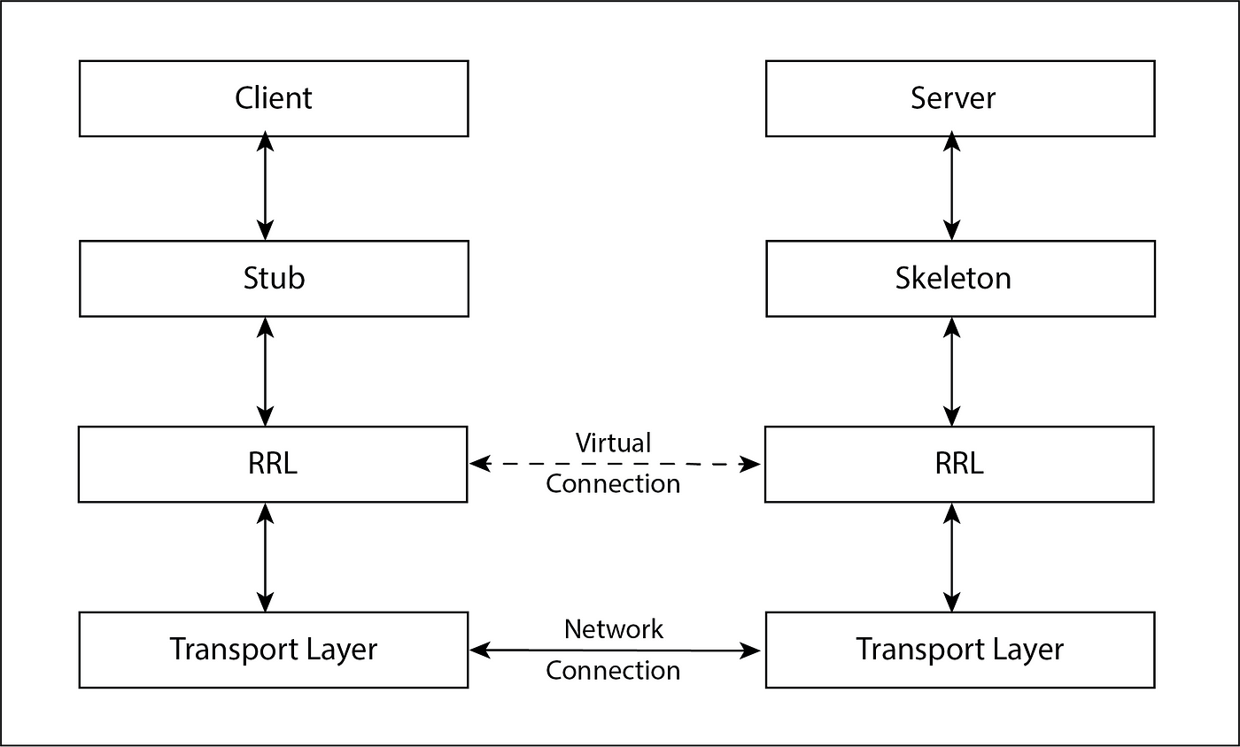
- The RMI (Remote Method Invocation) is an API that provides a mechanism to create distributed application in java. The RMI allows an object to invoke methods on an object running in another JVM.

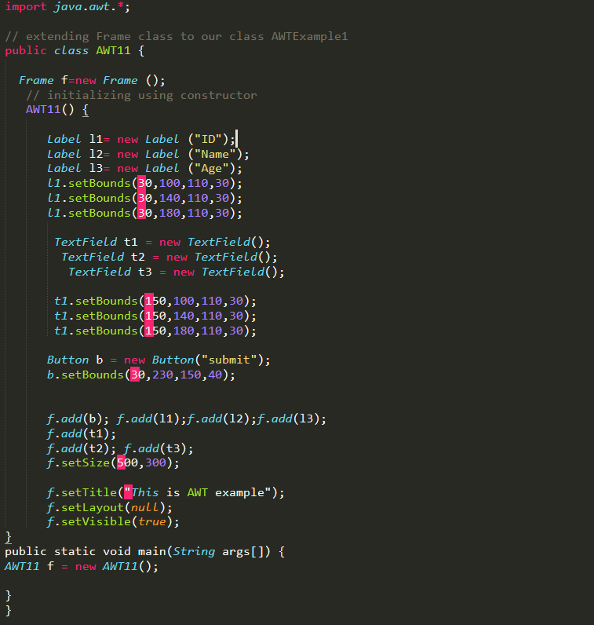

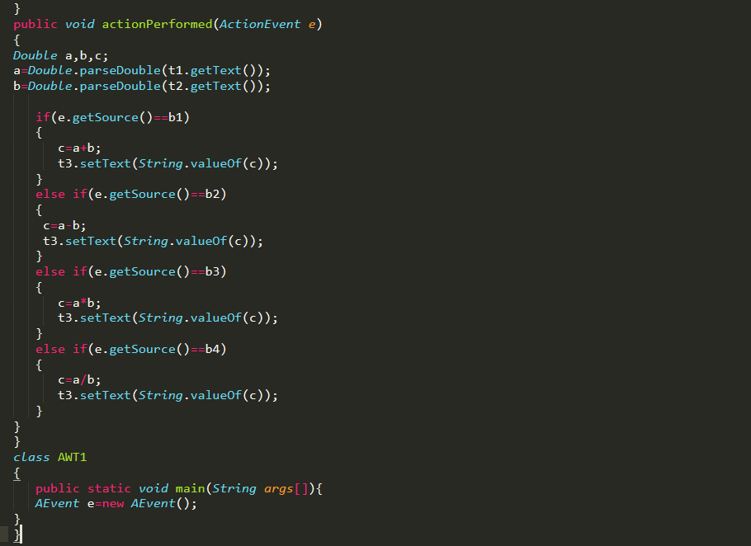
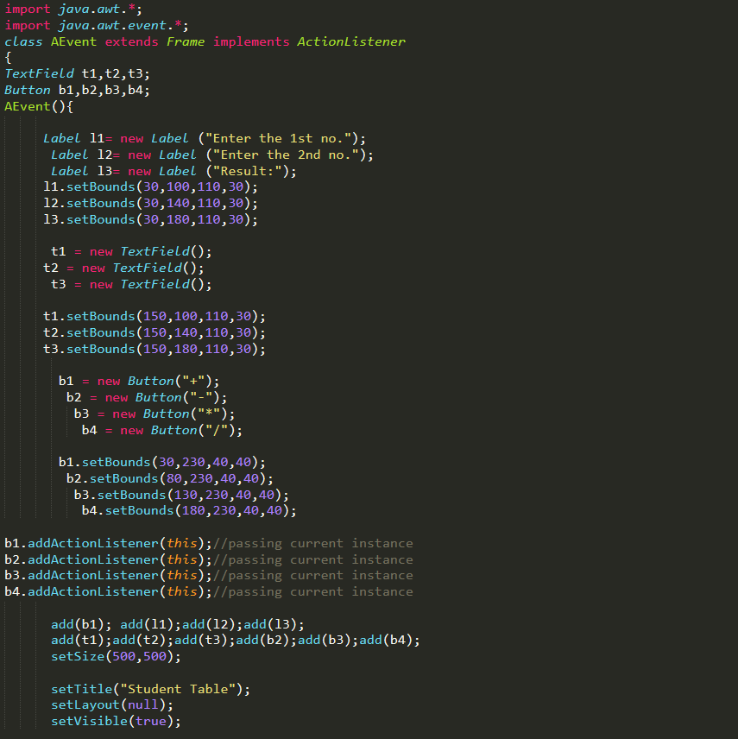
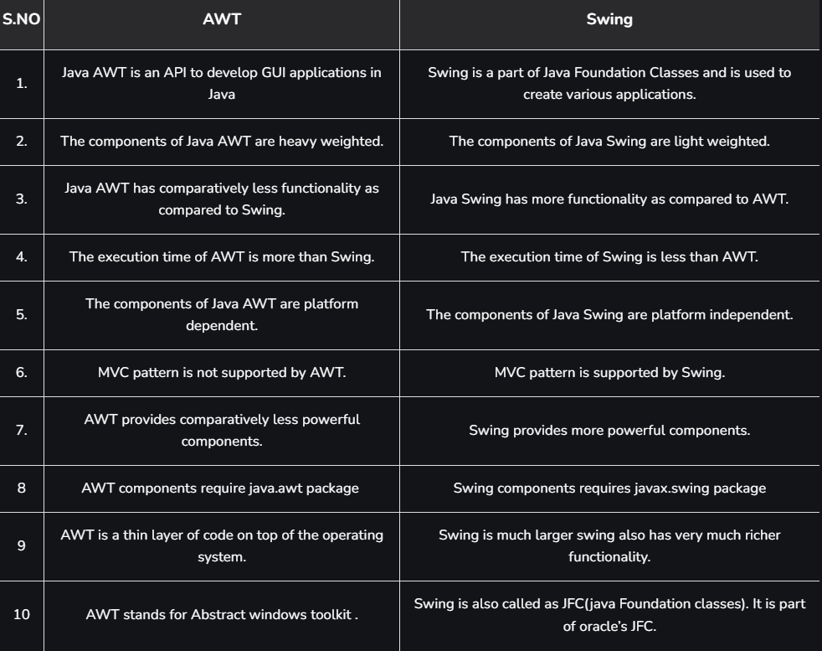

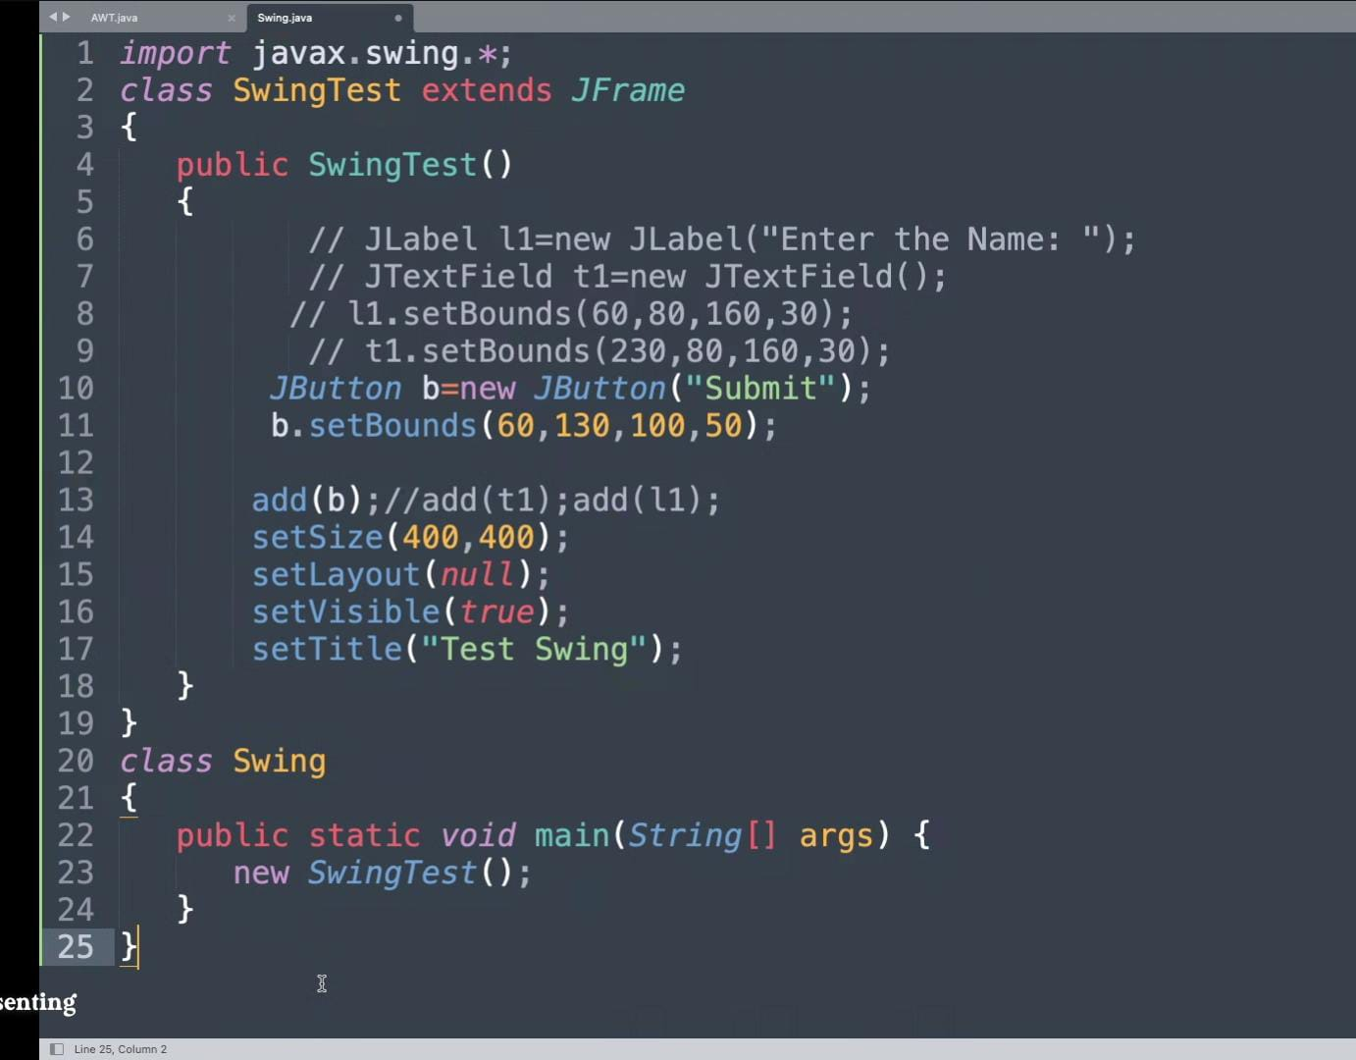

Understanding Stub and Skeleton Method In RMI: -

  - STUB: -
The stub is an object, acts as a gateway for the client side. All the outgoing requests are routed through it. It resides at the client side and represents the remote object. When the caller invokes method on the stub object, it does the following tasks:

- It initiates a connection with remote Virtual Machine (JVM)
- t writes and transmits (marshals) the parameters to the remote Virtual Machine (JVM),
- It waits for the result
- It reads (unmarshals) the return value or exception, and
- It finally, returns the value to the caller.

- SKELETON: -
The skeleton is an object, acts as a gateway for the server-side object. All the incoming requests are routed through it. When the skeleton receives the incoming request, it does the following tasks:

- It reads the parameter for the remote method
- It invokes the method on the actual remote object, and
- It writes and transmits (marshals) the result to the caller.

- JDBC (Java Database Connectivity): -

- JDBC stands for Java Database Connectivity. JDBC is a Java API to connect and execute the query with the database, and processing the results. It is a part of JavaSE (Java Standard Edition). JDBC API uses JDBC drivers to connect with the database.
- There are four types of JDBC drivers:
- JDBC-ODBC Bridge Driver.
- Native Driver.
- Network Protocol Driver.
- Thin Driver.

- JDBC-ODBC Bridge Driver:

The JDBC-ODBC bridge driver uses ODBC driver to connect to the database. The JDBC-ODBC bridge driver converts JDBC method calls into the ODBC function calls. This is now discouraged because of thin driver.

Advantages:
- easy to use.
- can be easily connected to any database.
Disadvantages:
- Performance degraded because JDBC method call is converted into the ODBC function calls.
- The ODBC driver needs to be installed on the client machine.

- NATIVE DRIVER:

The Native API driver uses the client-side libraries of the database. The driver converts JDBC method calls into native calls of the database API. It is not written entirely in java.

Advantage:
- Performance upgraded than JDBC-ODBC bridge driver.

Disadvantage:
- The Native driver needs to be installed on each client machine.
- The Vendor client library needs to be installed on client machine.

- NETWORK PROTOCOL DRIVER:

The Network Protocol driver uses middleware (application server) that converts JDBC calls directly or indirectly into the vendor-specific database protocol. It is fully written in java.

Advantage:
- No client-side library is required because of application server that can perform many tasks like auditing, load balancing, logging etc.

Disadvantages:
- Network support is required on client machine.
- Requires database-specific coding to be done in the middle tier.
- Maintenance of Network Protocol driver becomes costly because it requires database-specific coding to be done in the middle tier.

- THIN DRIVER:

The thin driver converts JDBC calls directly into the vendor-specific database protocol. That is why it is known as thin driver. It is fully written in Java language.

Advantage:

- Better performance than all other drivers.
- No software is required at client side or server side.

Disadvantage:

- Drivers depend on the Database.

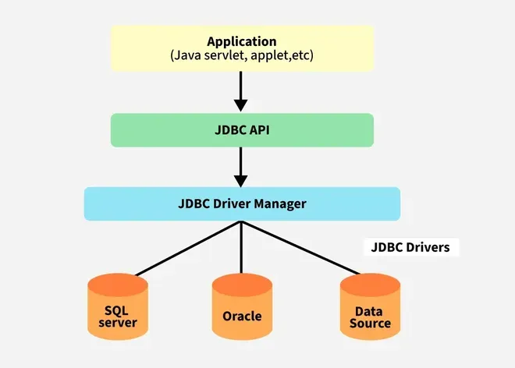
  - JDBC Architecture: -
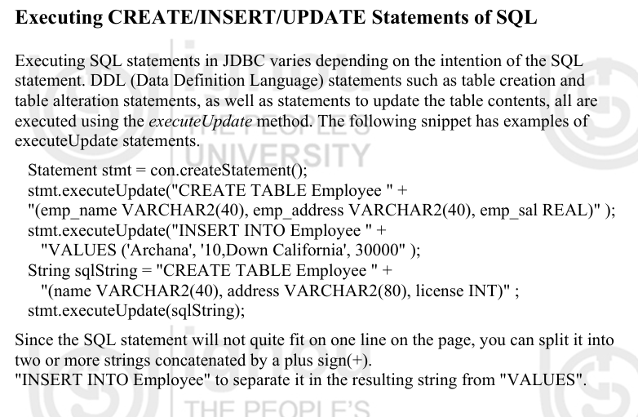
- Executing CREATE/INSERT/UPDATE Statements of SQL: -

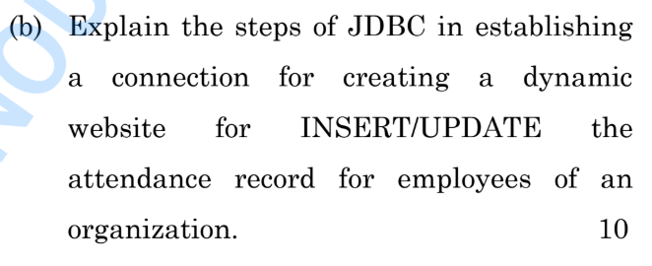
- HOW TO APPROACH THIS QUESTION SOLUTION GIVEN BELOW??
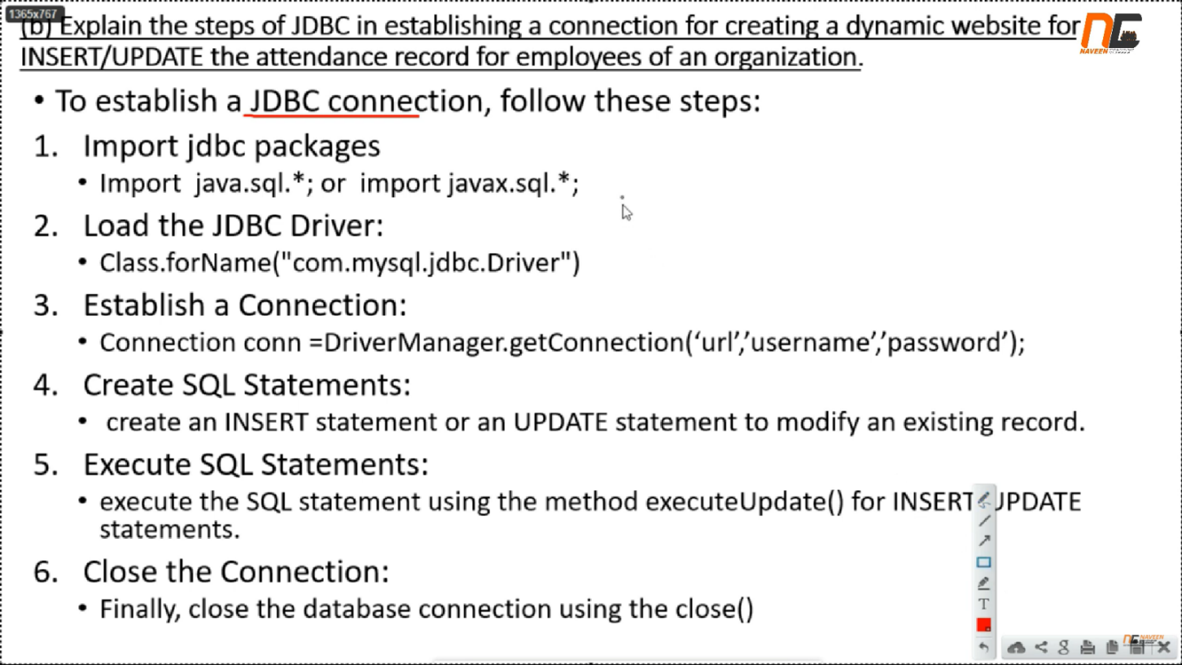
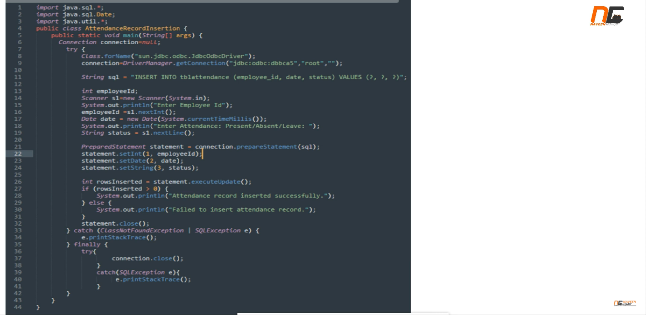

- JAVA SERVLET: -

The Java Servlet technology is robust and scalable because of java language. Its technology is used to create a web application, Java Servlet technology also defines HTTP-specific servlet classes.

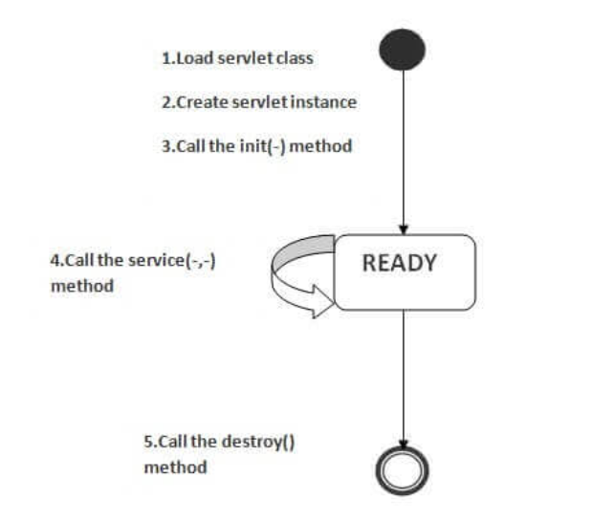
- Servlet Life Cycle: -

- JAVA BEANS: -

- A Java Bean is a reusable software component that can be visually manipulated in b builder tools. JavaBeans are classes that encapsulate many objects into a single object (the bean). It is a Java class that should follow the following conventions:
- Must implement Serializable.
- It should have a public no-arg constructor.
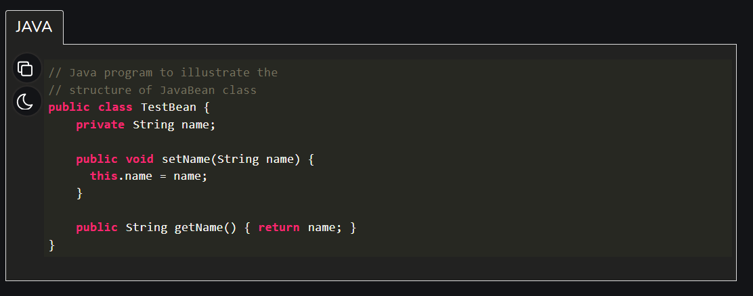
- All properties in java bean must be private with public getters and setter methods.
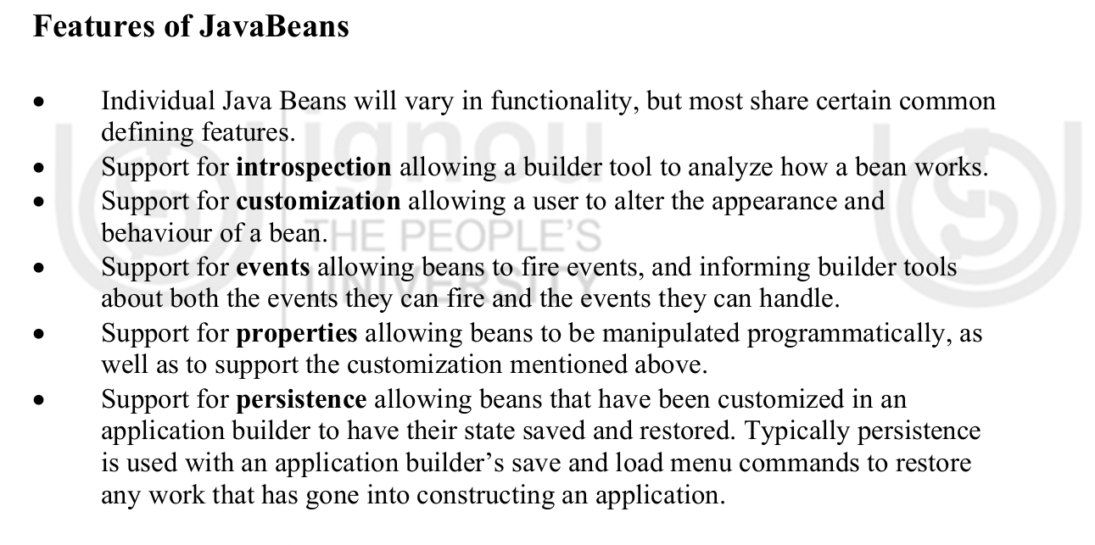
- GET and POST Methods in Servlet: -

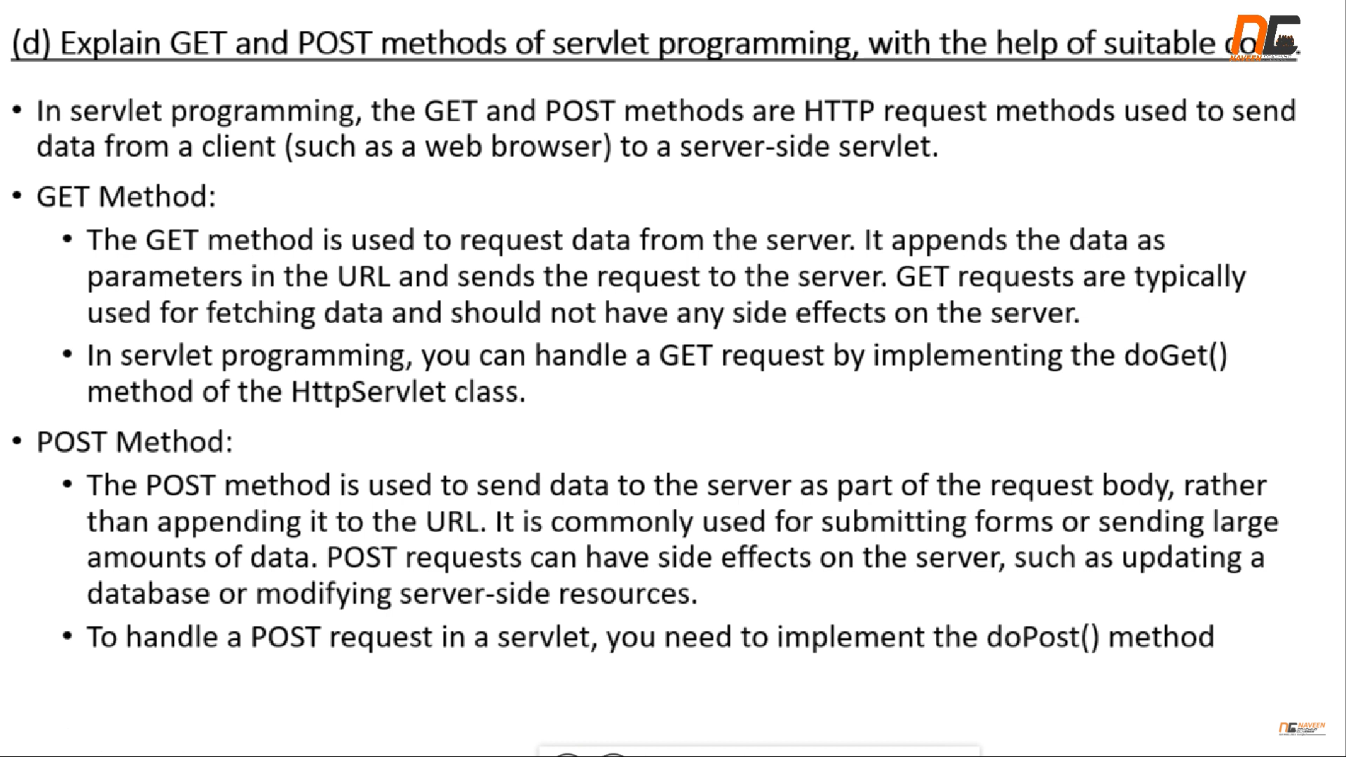

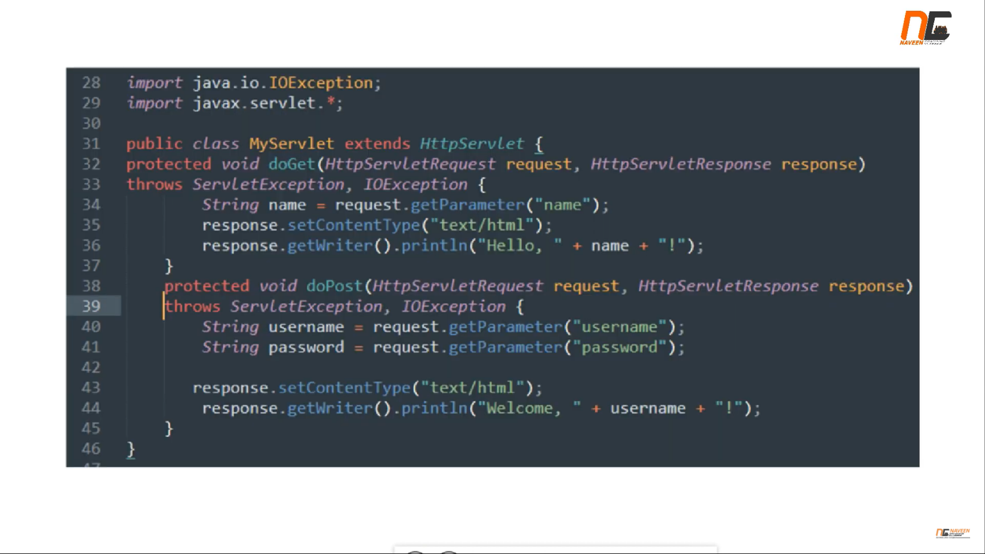

- SESSION HANDLING “OR” SESSION TRACKING: -

A session is sequence of HTTP request from the same client, over a period of time. HTTP is a “stateless” protocol, which means that each time a client requests a Web page, the client establishes a new connection with the Web server, and the server does not retain track of prior requests.

- The conversation of a user over a period of time is referred to as a session. In general, it refers to a certain period of time.
- The recording of the object in session is known as tracking.
- Session tracking is the process of remembering and documenting customer conversations over time. Session management is another name for it.
- The term “stateful web application” refers to a web application that is capable of remembering and recording client conversations over time.

- Why is Session Tracking Required?
- Because the HTTP protocol is stateless, we require Session Tracking to make the client-server relationship stateful.
- Session tracking is important for tracking conversions in online shopping, mailing applications, and E-Commerce applications.
- The HTTP protocol is stateless, which implies that each request is treated as a new one. As you can see in the image below.

- There are various ways through which you maintain the state: -

- Hidden Form Fields.
- URL Rewriting.
- Session Handling.
- Cookies (Session Variable).

- Hidden Form Fields: -

Hidden form fields are HTTP tags that are used to store information that is invisible to the user. In terms of session tracking, the hidden form field would be used to hold a client’s unique session id that is passed from the client to the server on each HTTP request.

- URL REWRITING: -

With each request and return, append some more data via URL as request parameters. URL rewriting is a better technique to keep session management and browser operations in sync.

- SESSION HANDLING: -

A user session is represented by the HTTP Session object. A session is established between an HTTP client and an HTTP server using the HTTP Session interface. A user session is a collection of data about a user that spans many HTTP requests.

- COOKIES: -

A cookie is a text file with a name, a value and a set of attributes. Using JSDK (Java Servlet Development Kit) it is possible sending coo e to save client’s state Kies. Cookies are sent from the server and saved on client’s system. On client’s system cookies are collected and managed by the web browser. For Used: -
  - Remembering login information.
  - Tracking user behaviour for analytics.
  - Saving user preferences (like theme or language).

- SESSION VARIABLES: -

Stored on the server-side. Temporary they last only as long as the session is active (usually until the browser is closed or session timeout). For Used: -
- Storing user data during a visit (like items in a shopping cart).
- Keeping a user logged in while they navigate different pages.
- Handling secure data without exposing it to the client.

- DIFFERENCE BETWEEN APPLETS AND SERVLESTS IS GIVEN BELOW?

APPLETS | SERVLETS
A Java applet is a small application which is written in Java and delivered to users in the form of bytecode. | A servlet is a Java programming language class used to extend the capabilities of a server.
Applets are executed on client side | Servlets are executed on server side
Life cycle of Applets init(), stop(), paint(), start(), destroy(). | Lifecycle of servlets are:- init( ), service( ), and destroy( ).
Applets utilize more network bandwidth as it executes on the client machine. | Servlets are executed on the servers and hence require less bandwidth.
Applets are more prone to risk as it is on the client machine. | Servlets are under the server security.
Applets use user interface classes like AWT and Swing. | No User interface required.

SCOKET OVERVIEW

- Most of the inter process communication uses the client server model.

- SOCKET: -
- The system calls for establishing a connection are different for the client and the server, but both involve the basic construct of a socket.
“OR”
- Socket is a data structure that maintains necessary information used for communication between client & server. Therefore, both end of communication has its own sockets.

- STREAM SOCKET: -

Stream Sockets are used to provide a connection-oriented service (i.e. TCP- Transmission Control Protocol). With stream sockets a process establishes a connection to another process. Once the connection is in place, data flows between processes in continuous streams.

- DATAGRAM SOCKET: -

A datagram socket serves as the sending or receiving point for a transmitted packet. Each packet sent or received on a socket is individually routed. A Datagram socket is a type of network socket that provides a connectionless endpoint for datagram packets.

- DATAGRAM PACKET: -

The Datagram Packet class is used to provide a facility for the connectionless transfer of messages from one system to another. This class provides tools for the production of datagram packets for connectionless transmission by applying the datagram socket class.

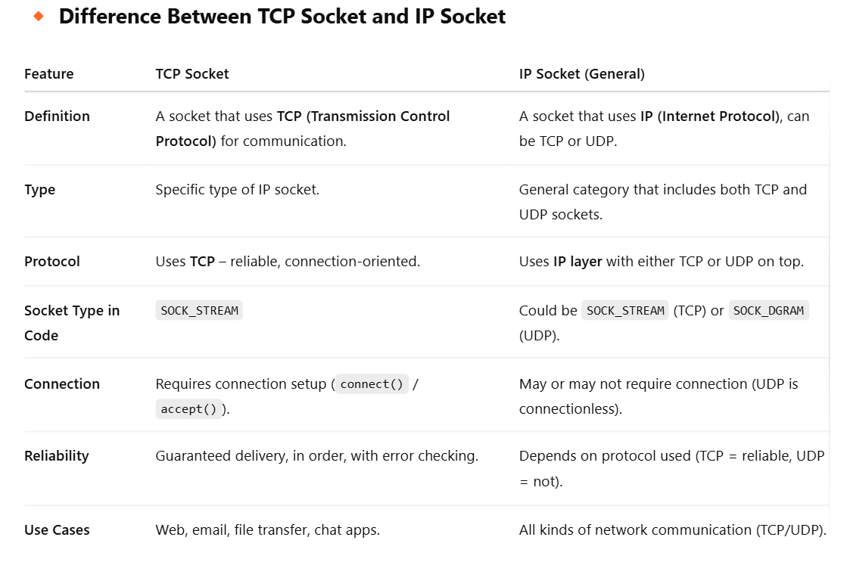
- SWING IN JAVA: -

- Java swing is a part of JFC (Java Foundation Classes) that is used to create window-based applications it is built on the top of AWT (Abstract Window Toolkit) API. Java Swing is a graphical user interface toolkit. Swing has provided java developers with robust framework for creating interactive, platform independent applications.

- Java Swing, a graphical user interface (GUI) toolkit, has been a cornerstone of Java development for decades. Since its inception, Swing has provided Java developers with a robust framework for creating interactive, platform-independent applications. In this article, we'll delve into the fundamentals of Java Swing, explore its key features, and discuss its relevance in modern application development

- KEY FEATURES: -

- Platform independent
- Rich set of components
- Customizability
- Event handling
- Layout Managers
- It supports MVC (Model View Controller)

- HIERARCHY OF JAVA SWING CLASSES: -
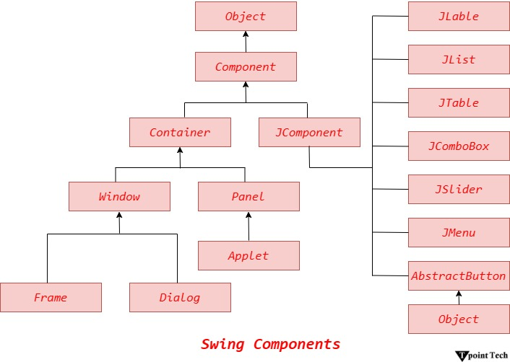
- LAYOUT MANAGERS: -

- The Layout Managers are used to arrange components in a particular manner. The Java Layout Managers facilitates us to control the positioning and size of the components in GUI forms. Layout Manager is an interface that is implemented by all the classes of layout managers. There are many classes that represent the layout managers, some of them are: -

- java.awt. BorderLayout
- java.awt. FlowLayout
- java.awt. GridLayout
- java.awt. GridBagLayout
- java.awt, CardLayout

- FLOW LAYOUT: -
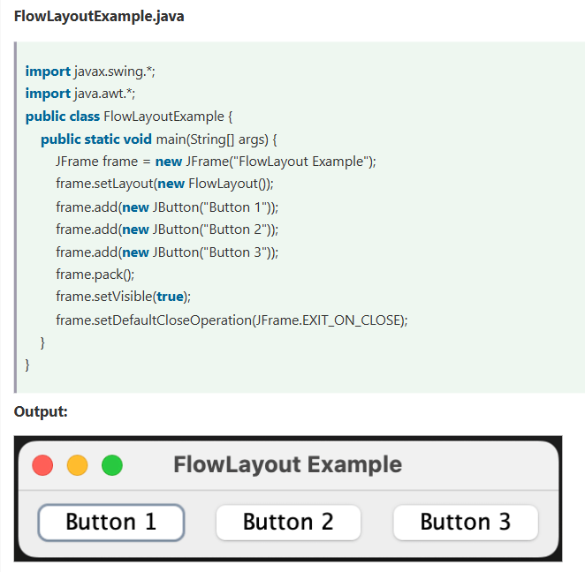
Flow Layout is a simple layout manager that arranges components in a row, left to right, wrapping to the next line as needed. It is ideal for scenarios where components need to maintain their natural sizes and maintain a flow-like structure.
- BORDER LAYOUT: -
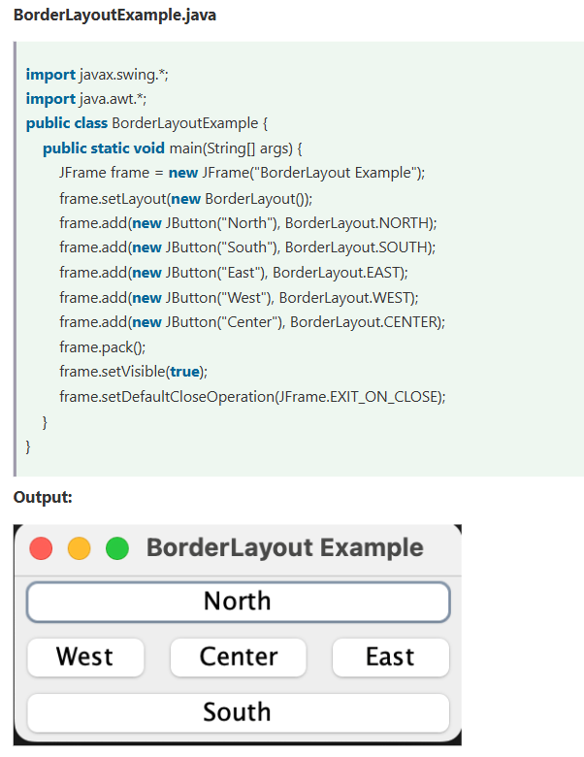
Border Layout divides the container into five regions: NORTH, SOUTH, EAST, WEST, and CENTER. Components can be added to these regions, and they will occupy the available space accordingly. This layout manager is suitable for creating interfaces with distinct sections, such as a title bar, content area, and status bar.

- GRID LAYOUT: -
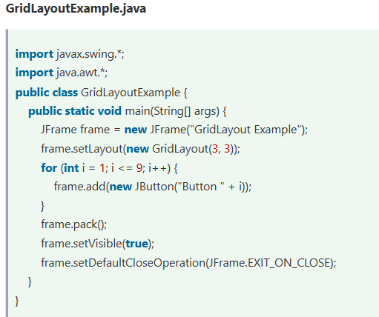
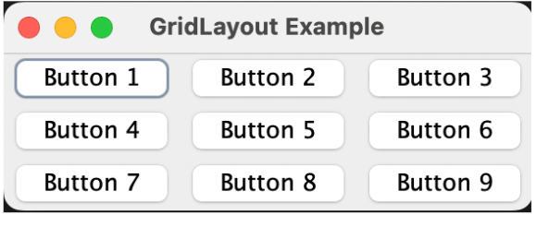
A Grid Layout divides an applet into a specified number of rows and columns, which form a grid of cells, each equally sized and spaced. It is important to note that each is equally sized and spaced as there is another similar named Layout known as GridBagLayout.
- CARD LAYOUT: -
CardLayout allows components to be stacked on top of each other, like a deck of cards. Only one component is visible at a time, and you can switch between components using methods like next() and previous(). This layout is useful for creating wizards or multi-step processes
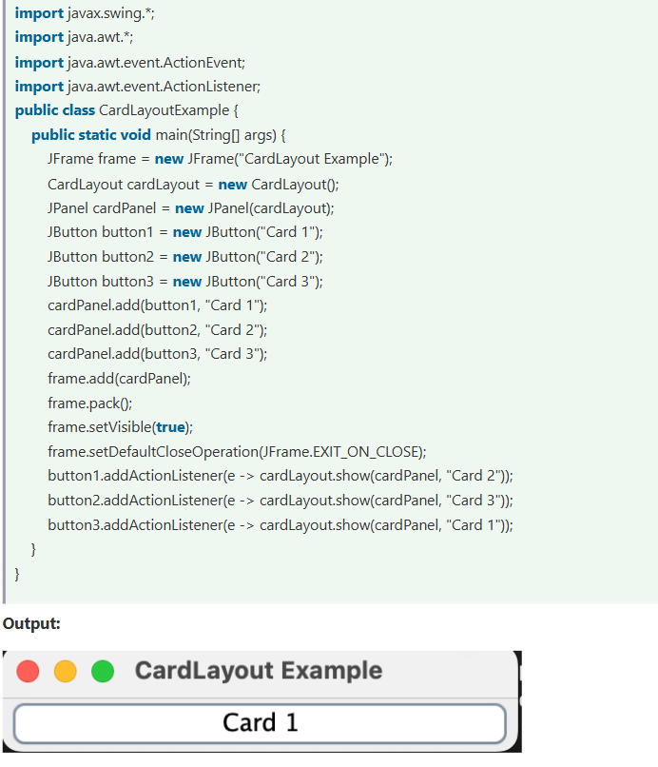

- GRID BAG LAYOUT: -
GridBagLayout is a powerful layout manager that allows you to create complex layouts by specifying constraints for each component. It arranges components in a grid, but unlike Grid Layout, it allows components to span multiple rows and columns and have varying sizes.
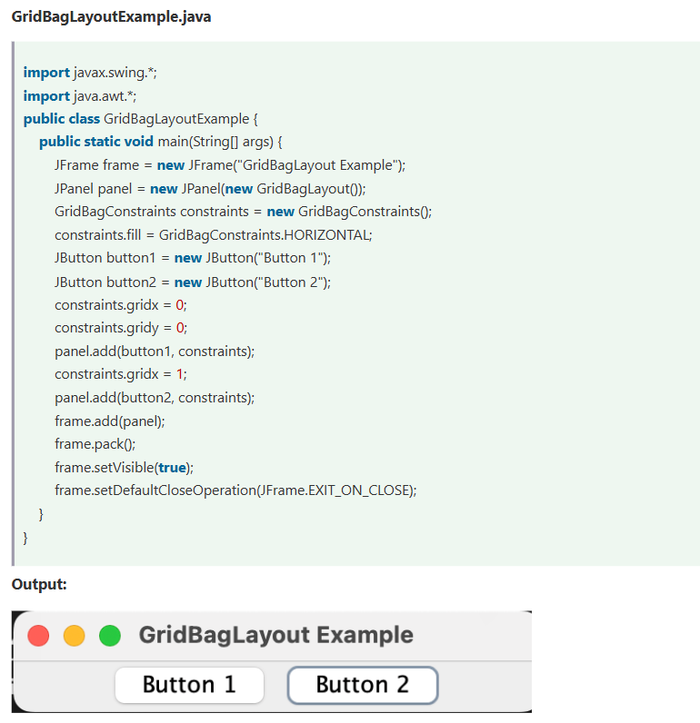

- APPLET IN JAVA: -

Applet is a special type of program that is embedded in the webpage to generate the dynamic content. It runs inside the browser and works at client side.

- Advantage of Applet: -

- It works at client side so less response time.
- Secured
- It can be executed by browsers running under many plateforms, including Linux, Windows, Mac Os etc.

Drawback of Applet: -
- Plugin is required at client browser to execute applet.

- HIERARCHY OF APPLET: -

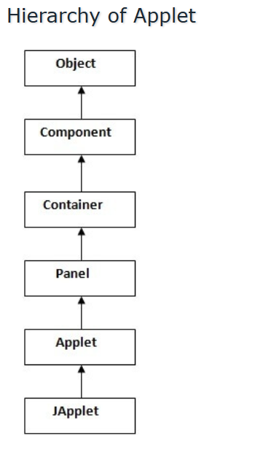

- LIFE CYCLE OF JAVA APPLET: -
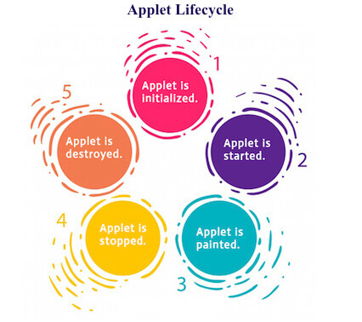

- Applet is initialized.
- Applet is started.
- Applet is painted.
- Applet is stopped.
- Applet is destroyed.

- LIFE CYCLE METHOD FOR APPLET: -

- The java. applet. Applet class 4 life cycle methods and java.awt. Component class provides 1 life cycle methods for an applet.
- Java. applet. Applet class: -

- For creating any applet java. applet. Applet class must be inherited. It provides 4 life cycle methods of applet.

- public void init (): is used to initialized the Applet. It is invoked only once.
- public void start (): is invoked after the init () method or browser is maximized. It is used to start the Applet.
- public void stop (): is used to stop the Applet. It is invoked when Applet is stop or browser is minimized.
- public void destroy (): is used to destroy the Applet. It is invoked only once.

- Java. awt. Component class: -

1. public void paint (Graphics g): It is used to paint the Applet. It provides Graphics class object that can be used for drawing oval, rectangle, arc etc.

SIMPLE EXAMPLE OF APPLET BY HTML FILE: -

- To execute the applet by html file, create an applet and compile it. After that create an html file and place the applet code in html file. Now click the html file.
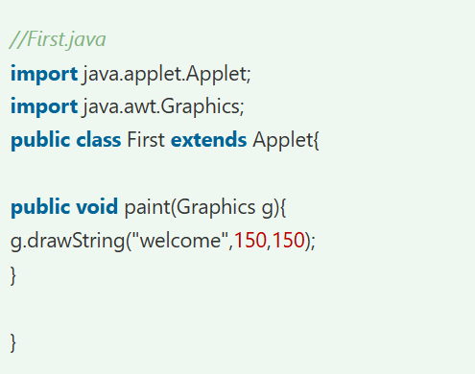

- STREAM TOKENIZER: -

- Stream Tokenizer Class is used to break any input stream into tokens, which are sets of bits delimited by different separator. A few separators already added while you can add other separators.

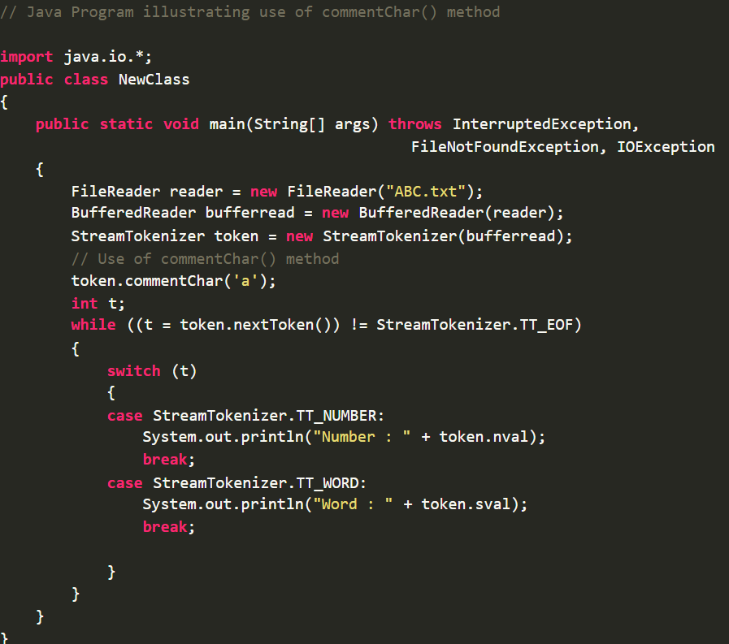
- This kind of parsing process is called “tokenizing”. A “token” is a sequence of characters that represents some abstract values stream. Tokenizer can identify members, quoted string and many other comment styles.

- SERIALIZATION: -

- Serialization in Java is a mechanism for writing an object's state into a byte stream. It is mainly used in Hibernate, RMI, JPA, EJB, and JMS technologies.

- The reverse operation of serialization is called deserialization, where the byte stream is converted into an object. The serialization and deserialization process is platform-independent. It means we can serialize an object on one platform and deserialize it on a different platform. For serializing the object, we call the writeObject() method of the ObjectOutputStream class, and for deserialization, we call the readObject() method of the ObjectInputStream class.

- Advantage of JAVA Serialization: -

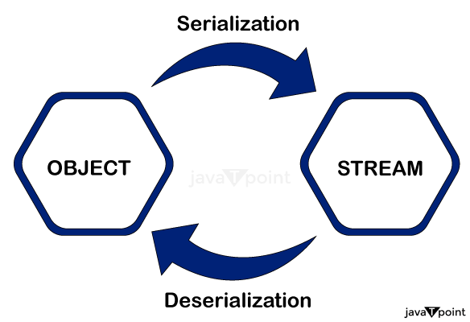

- Platform Independence: There are no compatibility problems when transferring serialized objects between separate Java virtual machines (JVMs) running on different platforms. Java Serialization is an effective technique for inter-system communication because of its platform independence.

- Network Communication: Java Serialization facilitates the transmission of object data over a network. This process, known as marshalling, allows objects to be serialized into a byte stream and sent across a network to be reconstructed on another machine.

- Object Persistence: Serialization allows for indefinite storage of object state. Data can be kept between program executions by using serialized objects, which can be saved to a disc or a database and then retrieved.
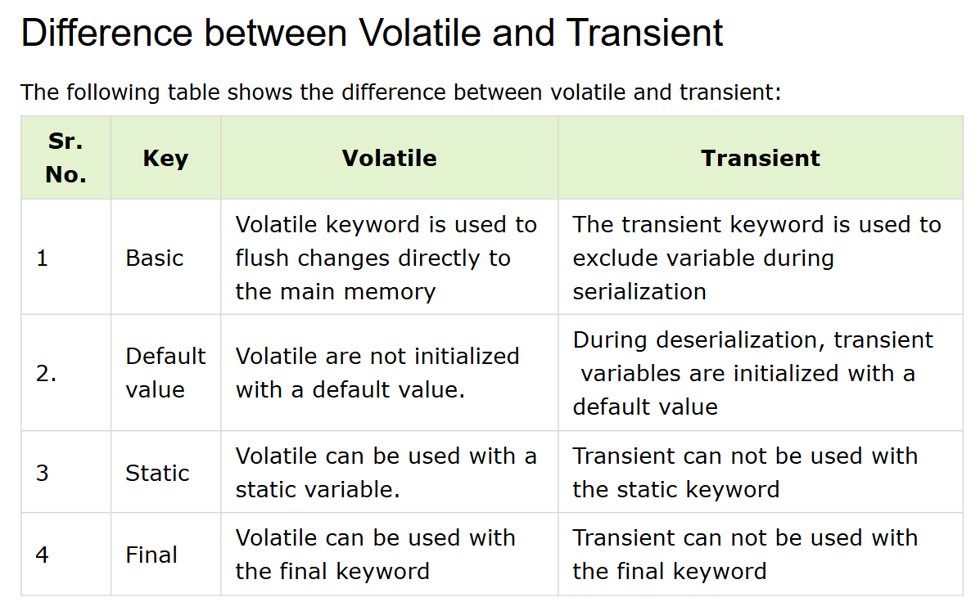
- BUFFERED STREAM: -

- A BufferedInputStream adds functionality to another input stream-namely, the ability to buffer the input and to support the mark and reset methods. When the BufferedInputStream is created, an internal buffer array is created. As bytes from the stream are read or skipped, the internal buffer is refilled as necessary from the contained input stream, many bytes at a time.
- BufferedInputStream (InputStream in): Creates a BufferedInputStream and saves its argument, the input stream in, for later use.
- BufferedInputStream (InputStream in, int size): Creates a BufferedInputStream with the specified buffer size, and saves its argument, the input stream in, for later use.
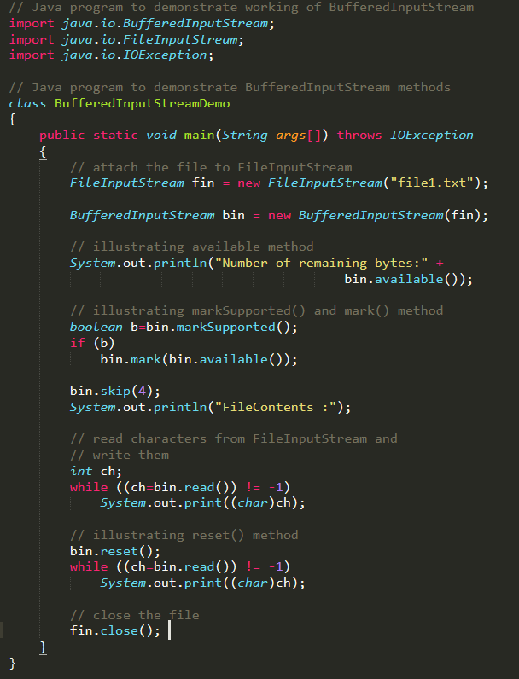
- STRING BUFFER: -

- Java StringBuffer class is used to create mutable string objects. The String Buffer class in java is the same as String class, except it is mutable, i.e., it can be changed. Java StringBuffer class is Thread safe, i.e., Mutable threads cannot access it simultaneously, so it is safe and will result in an order.

- Constructor of StringBuffer Class: -

- StringBuffer (): - creates an empty StringBuffer, with the initial capacity of 16 characters.
- StringBuffer (” <String>”): - creates a StringBuffer with the specified String
- StringBuffer(<length>): - creates an empty StringBuffer with the length as specified capacity.

- Methods of StringBuffer Class: -

- append (String str): - used to append a string at the end of StringBuffer.
- replace (int start index, int end index, String new Replacement): - used to replace a certain portion of StringBuffer (from start index to end index) with a new String/ new Replacement.
- delete (start index, end index): - used to delete all characters from start index to end index
- length (): - returns the current length of the StringBuffer
- capacity (): - used to return the capacity of the StringBuffer

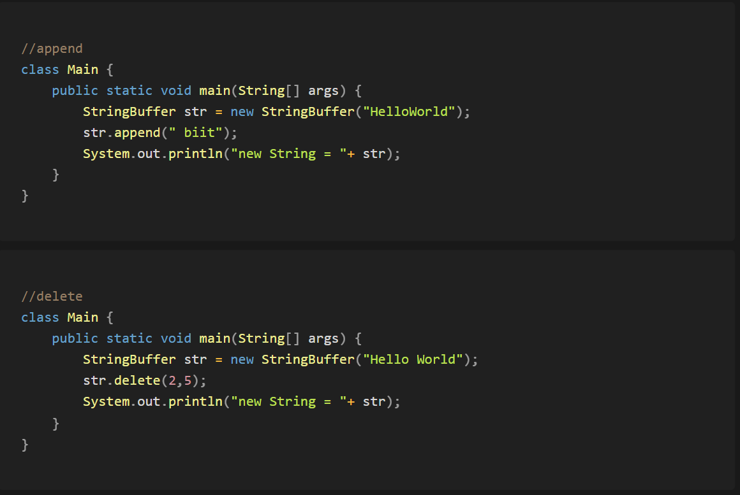

- STRING TOKENIZER: -
- StringTokenizer class in Java is used to break a string into tokens based on delimiters. A StringTokenizer object internally maintains a current position within the string to be tokenized. Some operations advance this current position past the characters processed.
- A token is returned by taking a substring of the string that was used to create the StringTokenizer object.
- It provides the first step in the parsing process often called lexer or scanner.
- It implements the Enumeration interface**. **
- To perform Java String Tokenization, we need to specify an input string and a set of delimiters.
- A delimiter is a character or set of characters that separate tokens in the string.
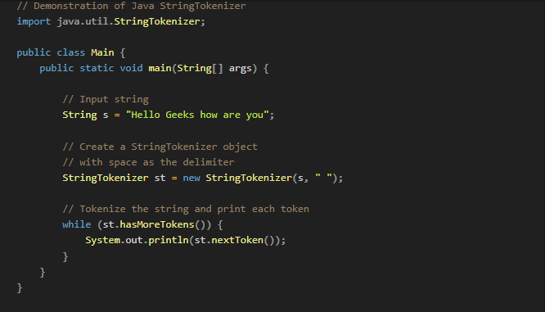

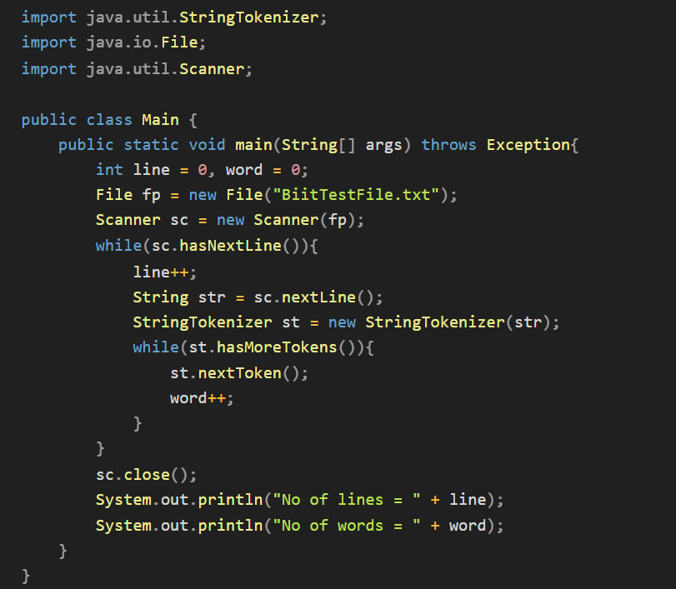

- ARRAY: -
Array is a collection of similar datatype elements stored at contagious memory location.


